**POWIS**

**Po**werfull **Wi**ndows **S**etup

This tool was developed to bring new user experience into Windows setup, supporting all Windows versions from Vista and newer.

**What features are added by POWIS?**

1. **Windows Recovery Environment** boot menu option
2. Multi-Unattended selector
3. Dynamic drivers folder
4. DriverPacks solution using **Snappy Driver Installer**
5. RunOnceEx setup phase
   1. Certificates installing from any **\*.CER files**
   2. Microsoft Office installing – 2007 or 2010 – 2016 or 2019 / 365 using **YAOCTRI**
   3. MSI Packages installing
   4. Products activation using **Multi-OEM/Retail Project {MRP} - Mk3** or your own custom **Activate.cmd**
   5. Updates installing
   6. Applications installing
   7. Apply personal settings from any **\*.REG** files
   8. DriverStore cleanup
   9. Scripts execution from any **\*.PS1** or **\*.BAT** or **\*.CMD** files
6. **ESD** support for Windows Vista and Windows 7

For example, this is how is changed setup structure in Windows 10 20H2v2. New folders and files that are reposponsible for whole magic are added

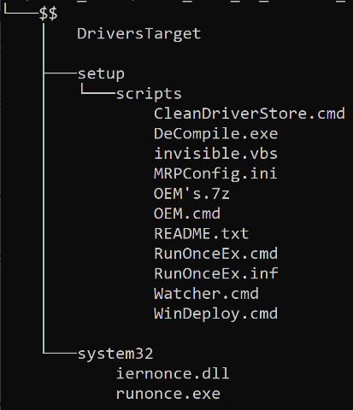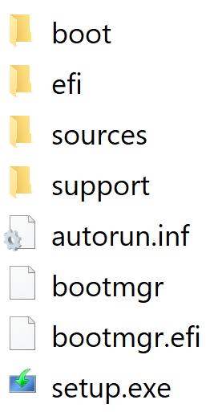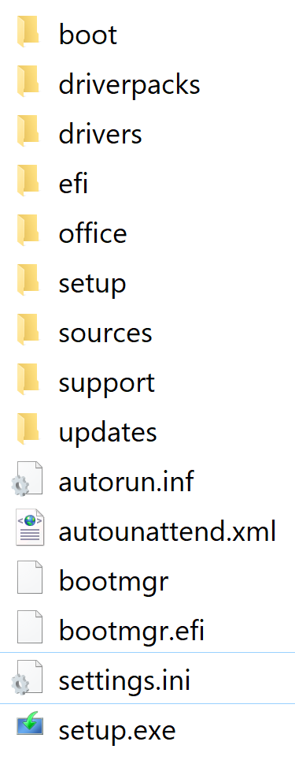

**$OEM$ folder**

**What is supported?**

1. Any architecture, build and language ISO or extracted setup of Windows Vista SP2*, Windows 7, Windows 8.0, Windows 8.1 and Windows 10. Servers are untested but they should work too. This could be pointed to bootable USB too.
2. Only clean installations are supported
3. Fully Unattended

\***NOTE: For dynamic drivers folder and automated skipping product key in Windows Vista is needed Windows 8.0 setup engine, if you want these features enable ESDSUPPORT option in config.ini**

**How to use POWIS?**

1. Download and extract this tool, for example to **C:\POWIS** directory
2. Prepare **plugins** folder. This folder needs your attention

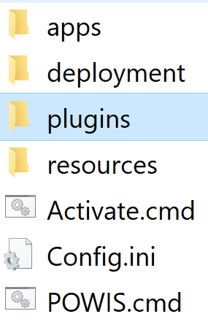 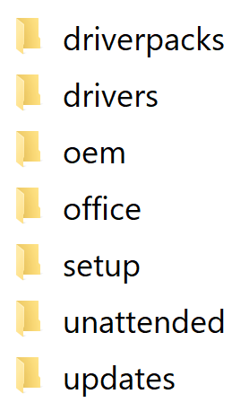

* 1. 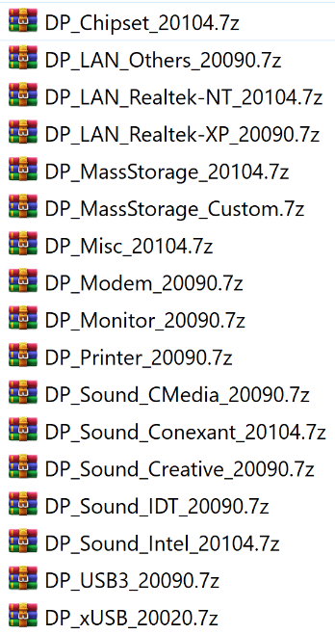**driverpacks** – place any compressed **\*.7z** DriverPacks here. **Snappy Driver Installer** install compatible drivers before first reboot of deployed system. All available languages in **SDI v1.21.2.2102** are mapped to Windows language codes. So perfect multilanguage support is available. If someone translate **SDI**, these new translations are needed to be hardcoded in **Launch.cmd**. You can find log files in **%WINDIR%\Logs**
  2. 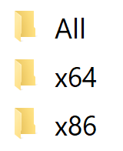**drivers** – if you want to apply drivers to deployed system before first boot.

Place drivers in INF format into certain folders. **All** directory is for architecture independent drivers, **x64** for 64bit drivers and **x86** is for 32bit drivers

* 1. 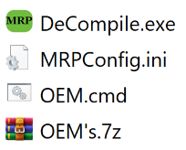**oem** – This folder is for **Multi-OEM/Retail Project {MRP} - Mk3** which is compatible with POWIS solution from **v137.1,** Download and extract this project. Needed files are *DeCompile.exe, OEM's.7z* and *OOBE.cmd*, then rename *OOBE.cmd* to *OEM.cmd.* You can find log files in **%WINDIR%\Logs**.On Windows 8 and newer you can see black screen during setup for a while. Don’t worry **MRP** isinstalled on background. This is caused by Windows setup design, on Windows 7 is this process different and you can see screen with *“Setup will continue after restarting your computer“* instead.
  2. **office** – All Office versions are supported. For **Office 2007** place unattended setup into **All** subfolder.This Office version is only 32bit and it will be installed on both x86 and x64 systems.For **Office 2010 – 2016** create **x86** and **x64** subfolders and place unattended setup into them. If you want to force 32bit Office on x64 systems place setup into **All** folder instead. For Office **2019 / 365** is supported **YAOCTRI** installation method. Just place generated setup directly into **office** folder. See pictures below

**Office 2007**

**Office 2010 - 2016**

**Office 2019 / 365**

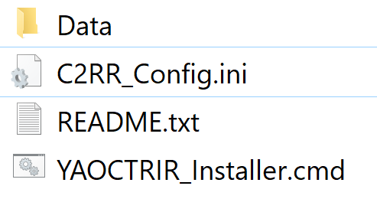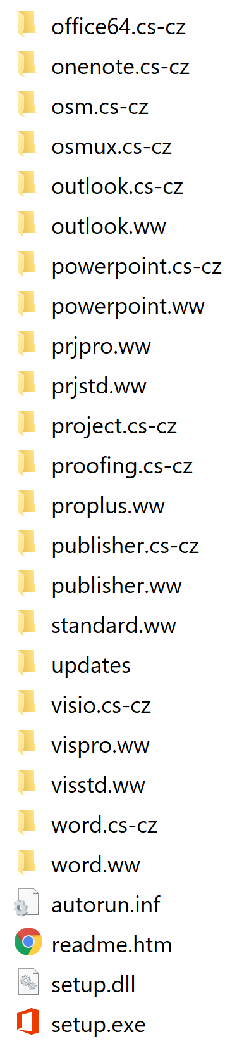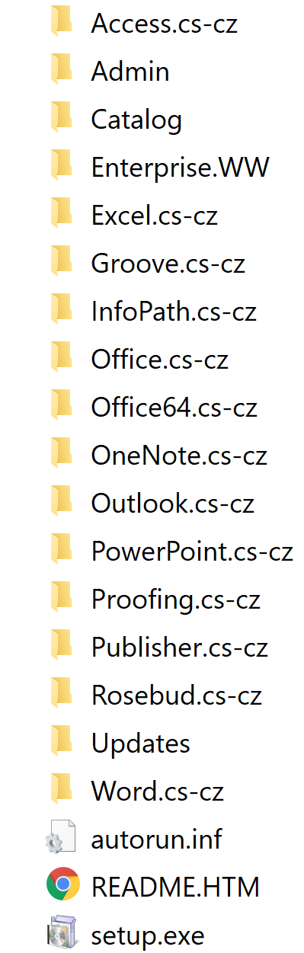

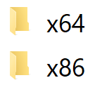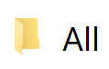

* 1. **setup** – This folder is here for your own **\*.CER**, **\*.PS1**, **\*.BAT**, **\*.CMD**, **\*.REG** , **EXE** and **MSI** files

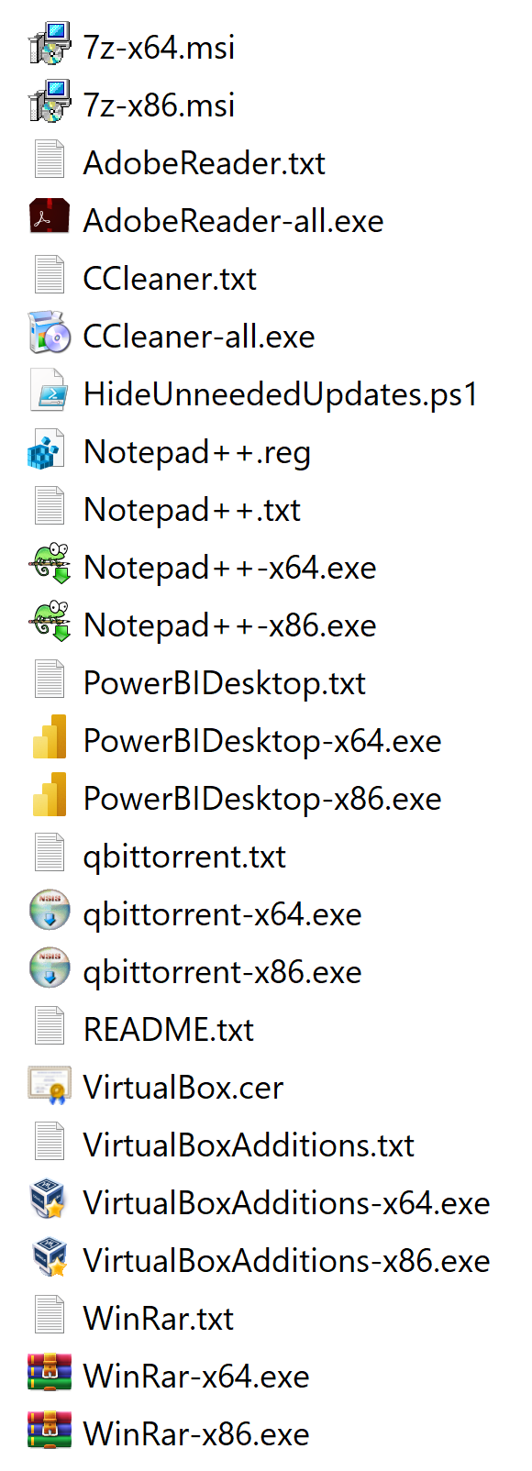During setup process is **setup** folder dynamically scanned, so you can add / remove files perfectly on the fly directly on your USB setup media.

You need to follow some rules when adding installers. If your applications have **EXE** installer for both architecture it must have **–all** in filename. If there exist standalone installers keep –**x86** and **–x64** in filename instead.

To define silent switch create simple **TXT** file with same name as application installer, but without architecture identificator. So for **WinRAR-x86.exe** and **WinRAR-x64.exe** is needed **WinRAR.txt** with **/S** inside as only single line.

**MSI** packages are installed automatically with **/quiet /norestart** switch. If you want to use your own switches do it in same way as you do for **EXE** installers.

**\*.CER**, **\*.PS1**, **\*.BAT**, **\*.CMD**, **\*.REG** are silently launched and applied. In scripts don't forget to **exit** them.

* 1. **unattended** – place any Unattended files here, if you do it, you will be prompted for selection when setup begin

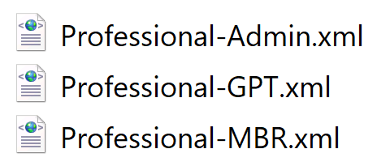

* 1. **updates** – place any updates files **\*.MSU**, **\*.CAB**, **\*.MSP** here and they will be silently installed. Just keep -**x86** and **-x64** in filename, simply follow the same logic as applications installers

1. Configure options in **Config.ini**

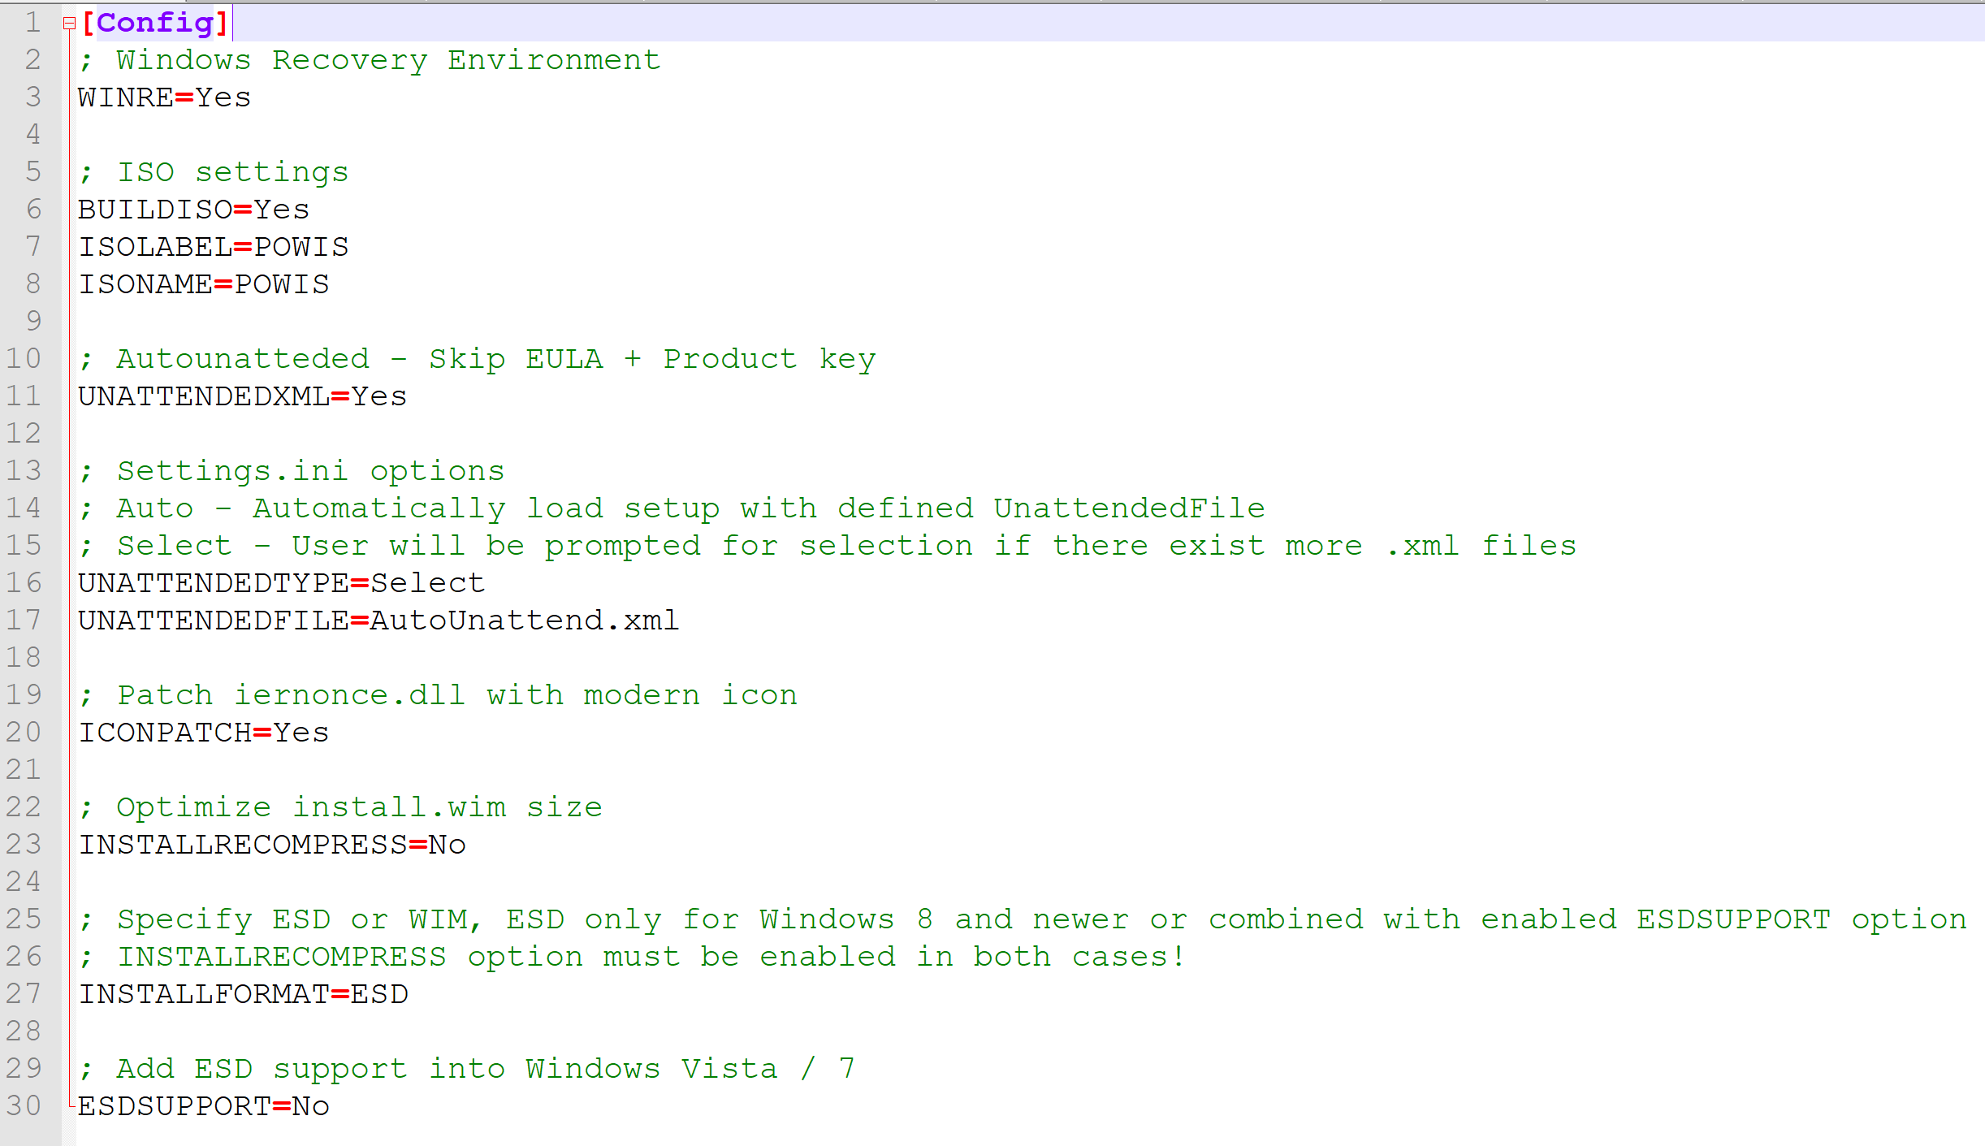

1. Launch **POWIS.cmd** as Administrator, then **drag and drop** extracted Windows setup path or ISO or already created bootable USB into console window. You can also use **POWIS** directly from **CMD** in your own scripts. See **POWIS.cmd /?** for more informations. When you point already created bootable USB, it must be without

**\ (backslash)**, like **E:** or **G:** not E:\ or G:\ otherwise **POWIS** end is fail with many errors. I tried to solve this, but on some languages is backslash differect character. So this must be carefully driven by user.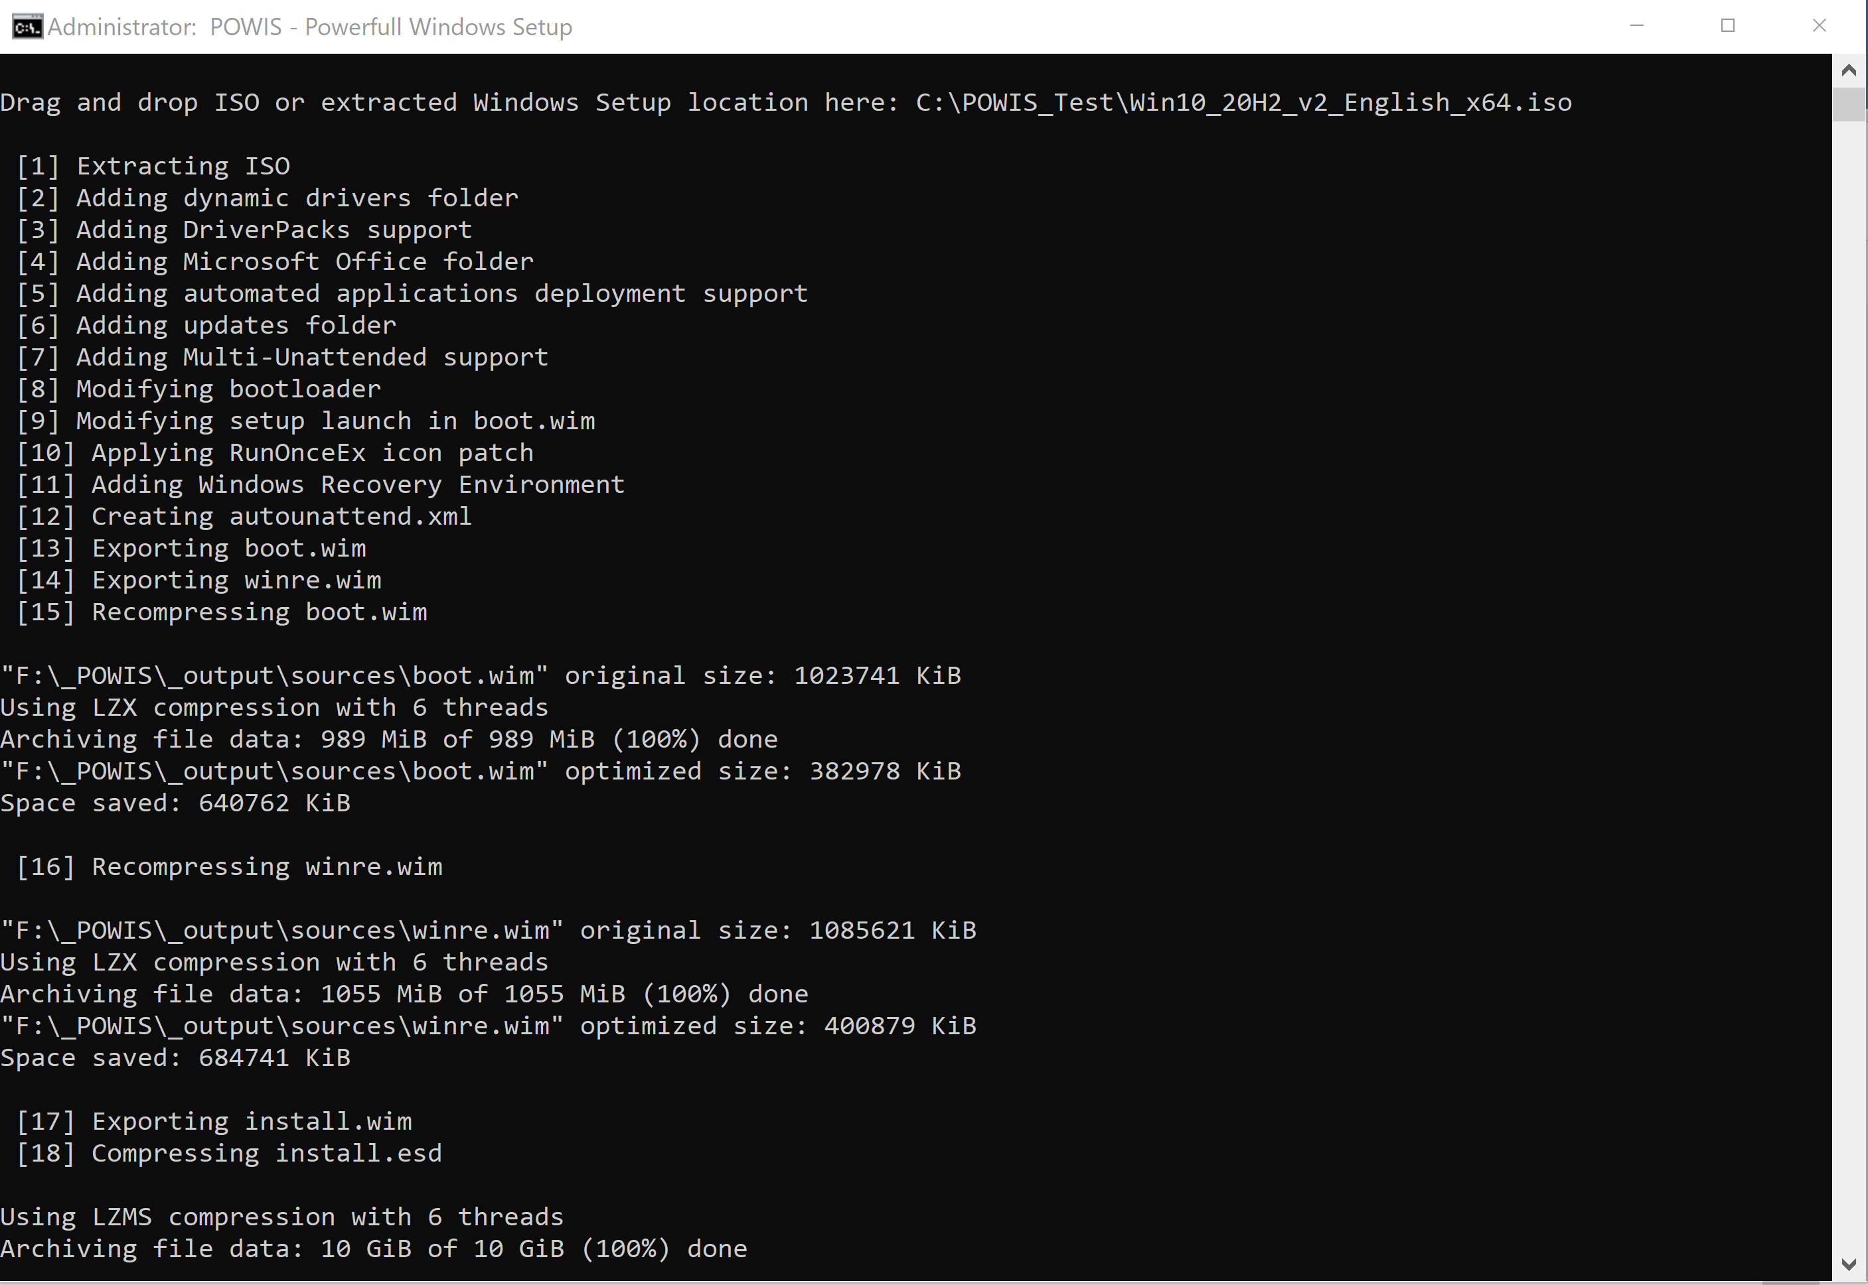

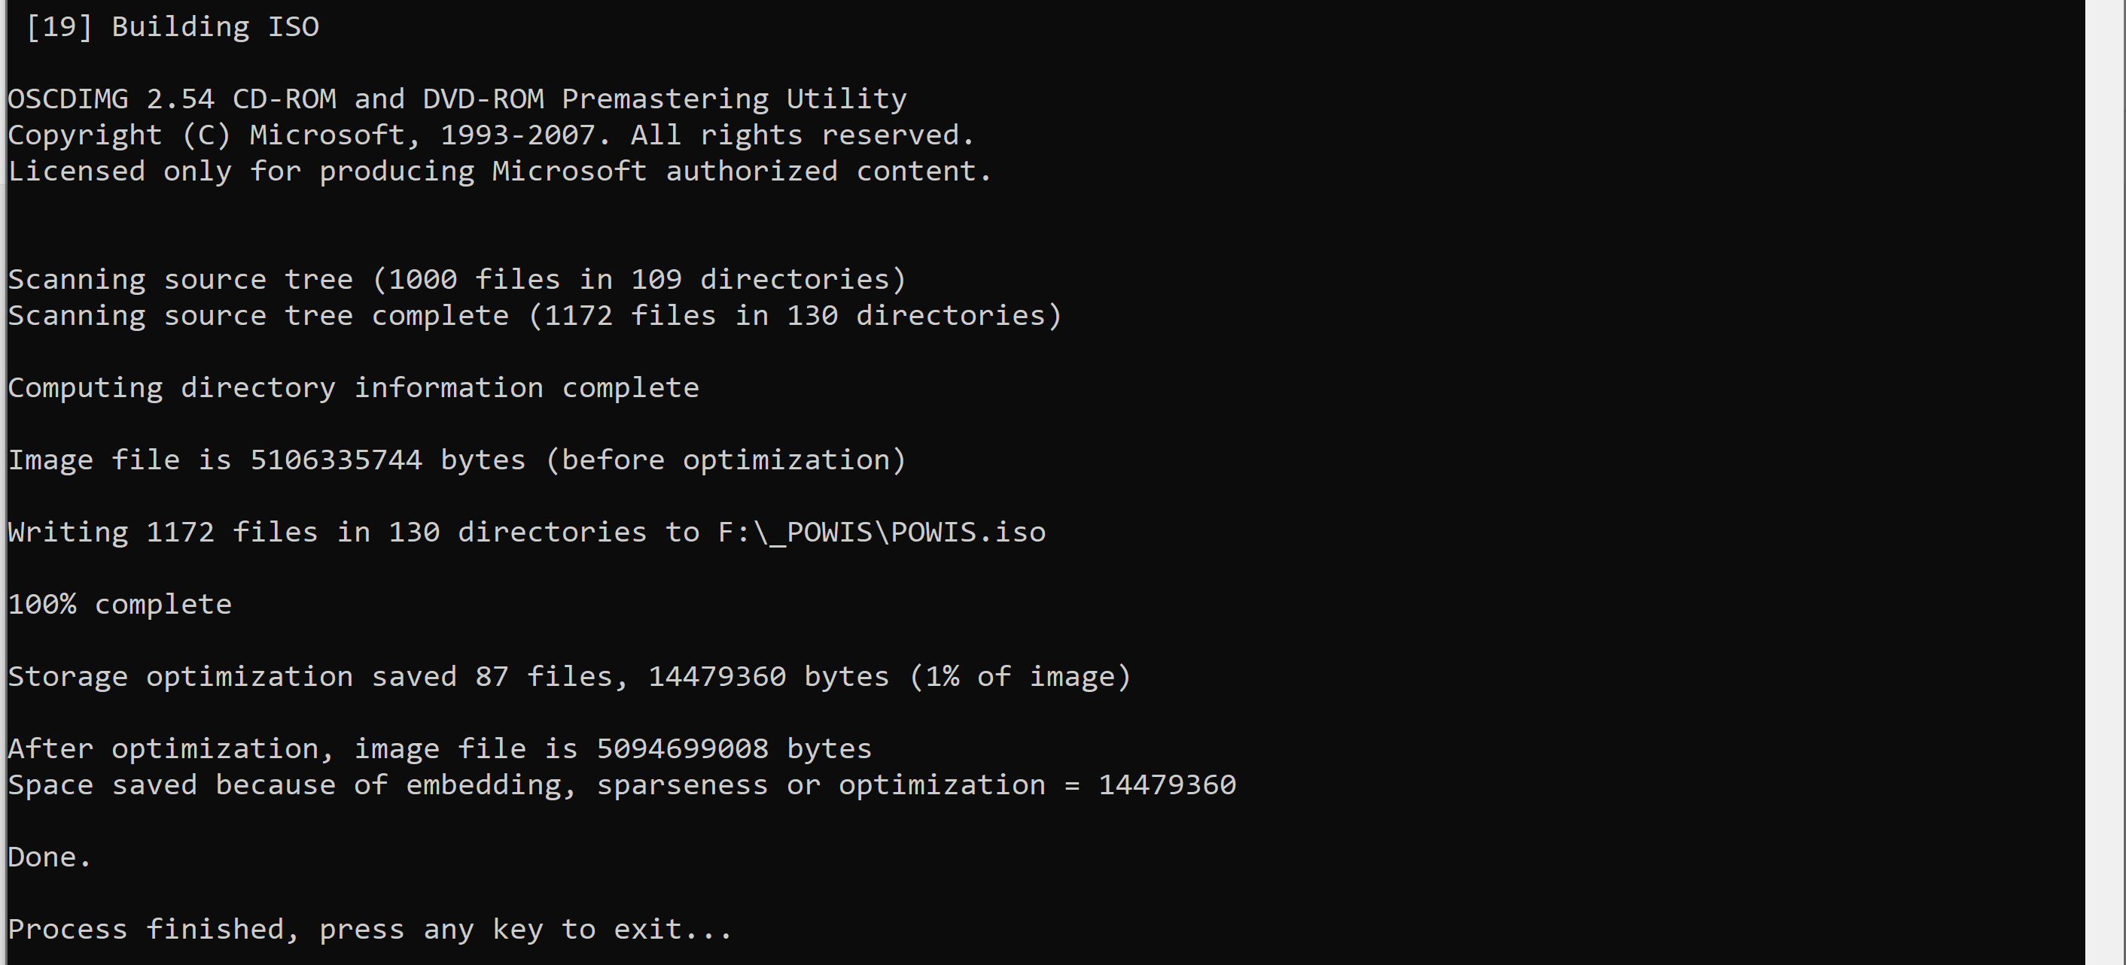

**What is RunOnceEx?**

RunOnceEx is old build-in Windows feature introduced firstly in Windows 95, which processing commands one by one. In **POWIS** solution are these steps generated by **RunOnceEx.cmd** on the fly during setup process. This is also solution for some special cases. ***1)*** Some applications needs created User account and can’t be installed through **SetupComplete.cmd**. RunOnceEx is processed under Administrator account so this limilation is gone. ***2)*** **SetupComplete.cmd** and **OOBE.cmd** are ignored during setup when OEM key is used. This limitation is also gone in **POWIS** solution with **RunOnceEx** setup phase. **NOTE:** *You can still use these files if you want, but they have their limitations explained above.*

To be able to run this solution was developed **Watcher.cmd**. Small script that runs on background when **RunOnceEx** is launched to watch every 1 second for **explorer.exe** and **sysprep.exe** in Task manager, as these processes needs to be killed immediately after they appears to avoid unneeded user touch and bring better and clean user experience.

All steps are readed dynamically, so you can view all 10 steps or only few of them.

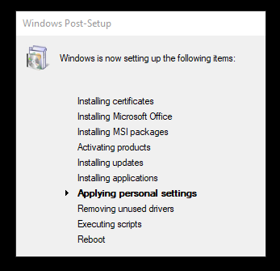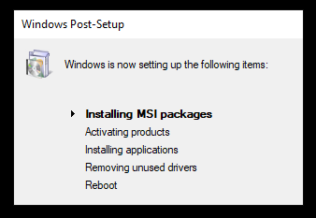

This dialog is translatable through **RunOnceEx.inf**. It’s a small INF file with multilanguage strings, this is same method like drivers are localized. Currently are supported these languages. Many thanks for them to translators!

**English (en-US)  
Czech (cs-CZ)  
Brazilian Portuguese (pt-BR)  
Spanish (es-ES)  
Slovak (sk-SK)  
German (de-DE)  
Dutch (nl-NL)  
Norwegian Bokmål (nb-NO)  
Finnish (fi-FI)  
Bulgarian (bg-BG)  
Korean (ko-KR)  
French (fr-FR)  
Italian (it-IT)**

**Portuguese (pt-PT)  
Russian (ru-RU)**

If you want to add your language translation, please translate these strings and submit them with language name / language code. They will be added in next release.

*FINTEXT = "Windows Post-Setup"*

*CERTEXT = "Installing certificates"*

*SCRIPTTEXT = "Executing scripts"*

*OFFTEXT = "Installing Microsoft Office"*

*MSITEXT = "Installing MSI packages"*

*ACTTEXT = "Activating products"*

*UPDTEXT = "Installing updates"*

*SILTEXT = "Installing applications"*

*TWKTEXT = "Applying personal settings"*

*DRVCLNTEXT = "Removing unused drivers"*

*RBTTEXT = "Reboot"*

Examples of translated **RunOnceEx** into *Korean*, *Czech* or *Italian*. This can support any language

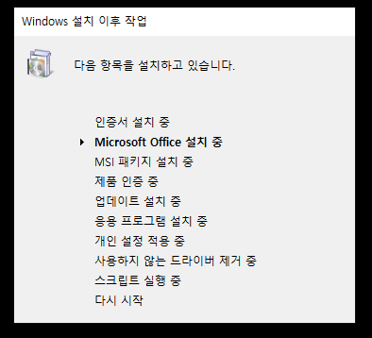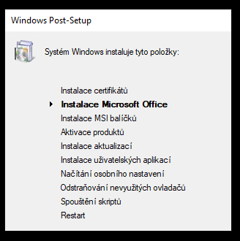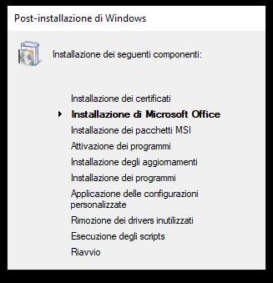

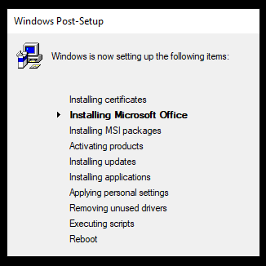

If you like old Window 95 setup style icon, disable **ICONPATCH** option in **config.ini**. I personally want new one instead. This is how original ugly old icon looks.

**NOTE:** When you are removing components with **NTLite** or any other slimming down tool. Keep protected these **Internet Explorer** files as they are responsible for RunOnceEx -

**iernonce.dll + iernonce.dll.mui + IEAdvpack.dll.** Here is also **NTLite** preset to make it easy.****

**What is Clean DriverStore feature?**

Have you integrated bunch of drivers into your image? **CleanDriverStore.cmd** is what every installed system with preintegrated drivers needs. All drivers that are not in use are automatically removed from DriverStore. **NOTE:** *Keep all devices connected during setup or your integrated drivers for these devices will be removed!* You can save a lot of space at installed machine. If you already updated your system drivers you can run **CleanDriverStore.cmd** as Administrator manually too! You can find log file in **%WINDIR%\Logs**.

**What is Multi-Unattended?**

If you have more unattended XML files present on ISO / USB you will be prompted for selection before setup start. You can easily perform different configuration from USB on the fly. Selector is visible only when more than 1 XML files exist in ISO / USB root, see **settings.ini** for more configuration. **NOTE:** ***NTLite*** *preset files are ignored*

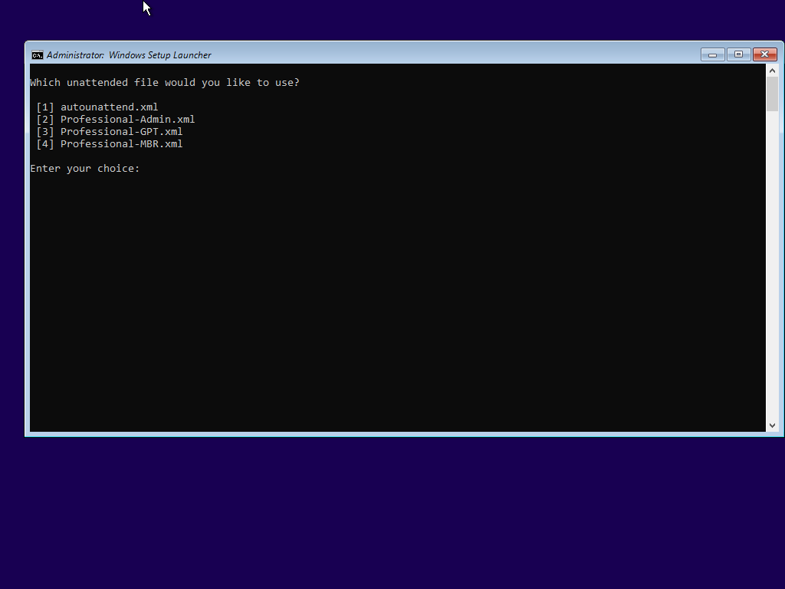

**How is provided ESD support for Windows Vista and Windows 7?**

Yes, it’s possible to bring ESD compression into these older operating systems. This is provided by upgrading setup engine inside WinPE, this mean **boot.wim is still original** from Windows Vista or Windows 7.

**POWIS** include **RES** patches, so setup looks same as original! To compress install.wim into install.esd you need to enable **ESDSUPPORT + INSTALLRECOMPRESS** options and set **INSTALLFORMAT** to **ESD**.

What you need to do is simple provide new setup engine

1. **Windows Vista** require exactly Windows 8.0. For example English Windows Vista Ultimate SP1 x64 ISO have 3,7GB, compressed to ESD with WinRE option is final ISO 2,6GB
   1. This bring dynamic drivers folder support too
   2. Small glitch exist in setup after first reboot – setup activate second step „Expanding files“, but don’t worry it’s only glitch and setup is succesfully finished
2. **Windows 7** require any Windows from Windows 8.0 and never, works with Windows 10 20H2 without problém. For example English Windows 7 Ultimate SP1 x64 ISO have 3,2GB, compressed to ESD with WinRE option is final ISO 2,4GB

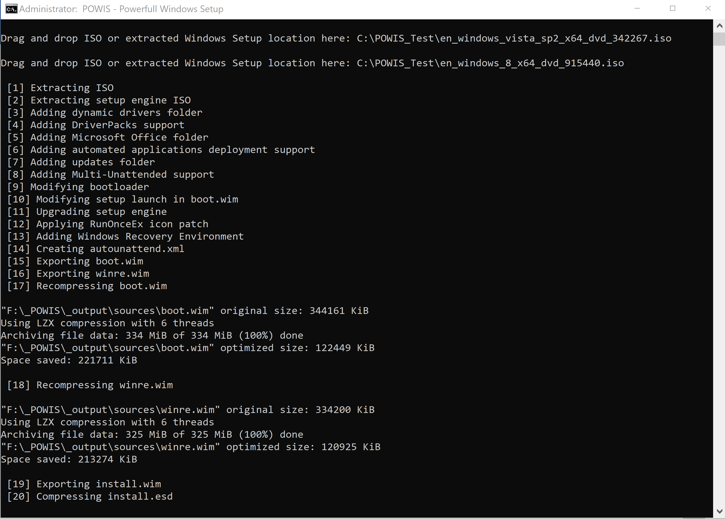

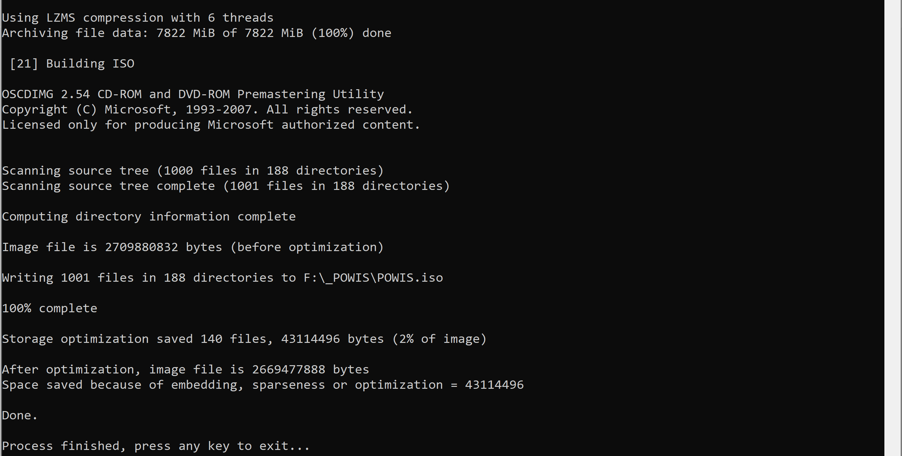

**How looks setup with applied POWIS?**

Whole Windows setup process is now more script driven. Due this method we are loosing **Windows Recovery Environment** option in setup known as **Repair PC** option. But this doesn’t matter as we added new boot option to **winre.wim** directly from sources folder to be able to enter **Windows Recovery Environment**.

**Windows Vista with POWIS**

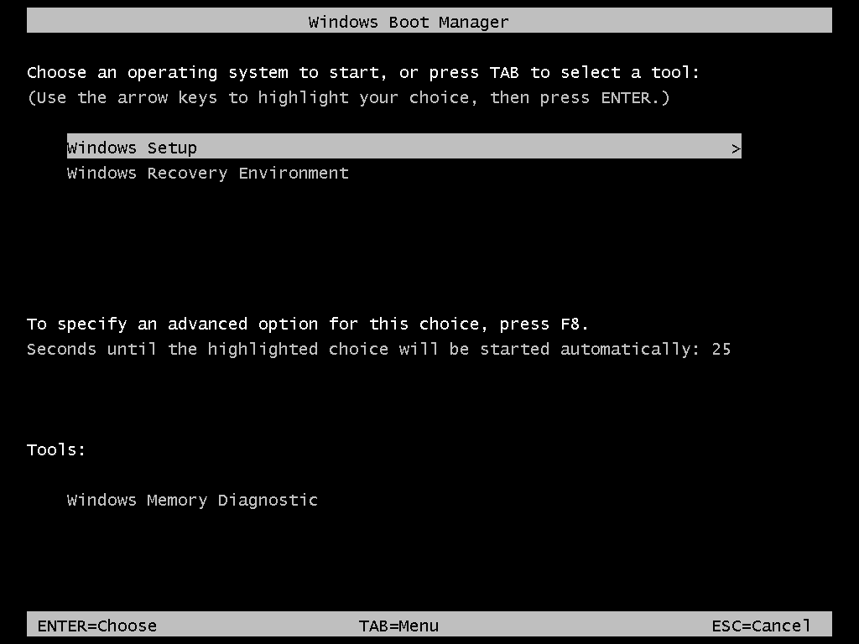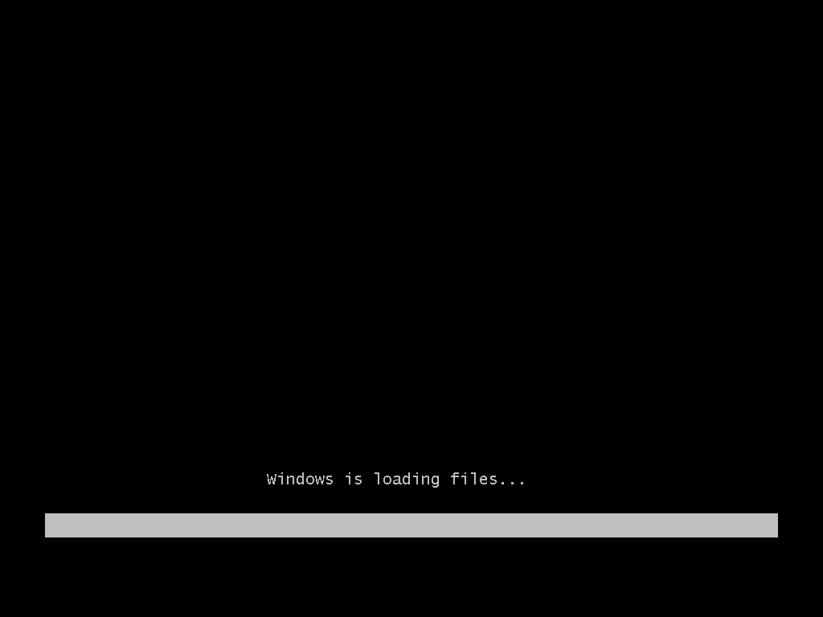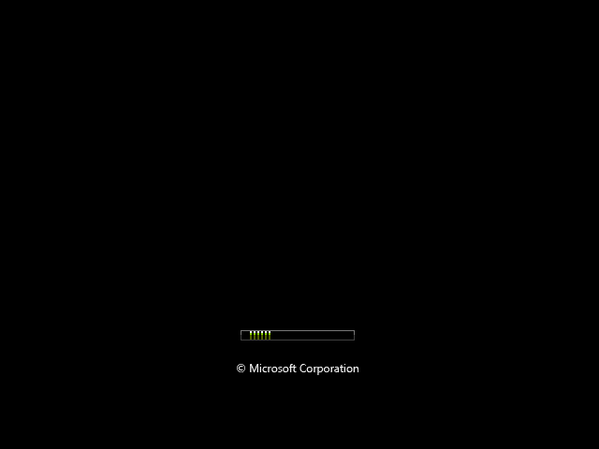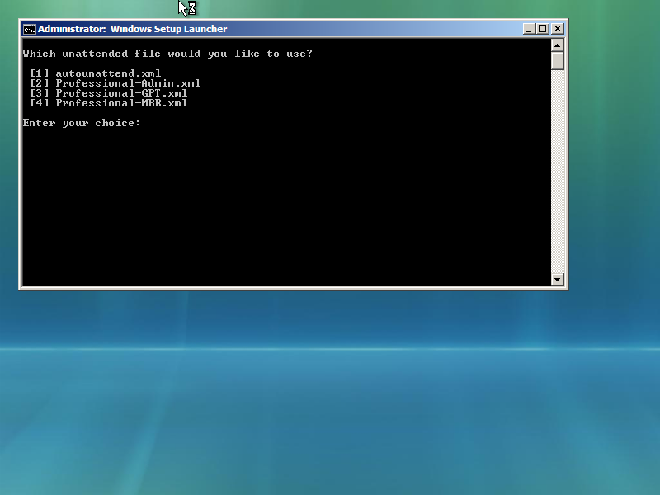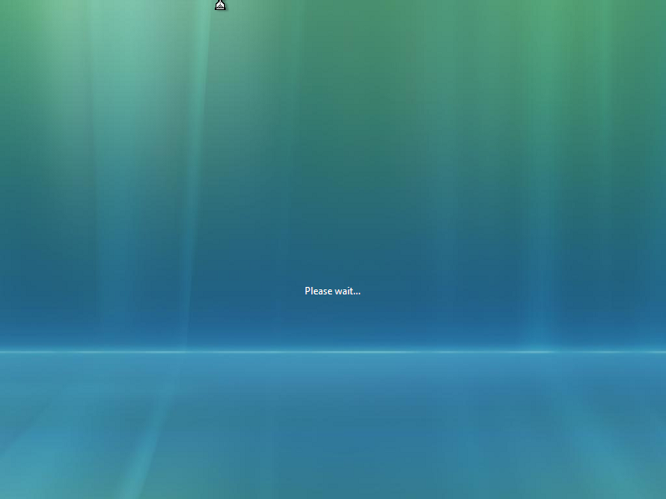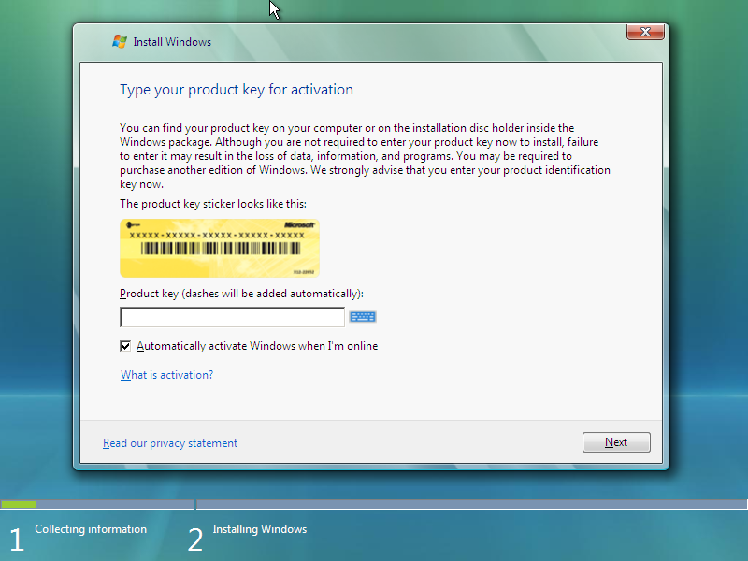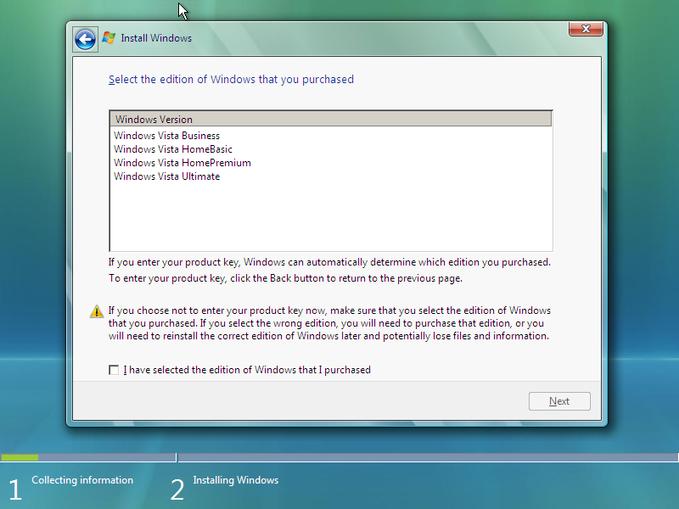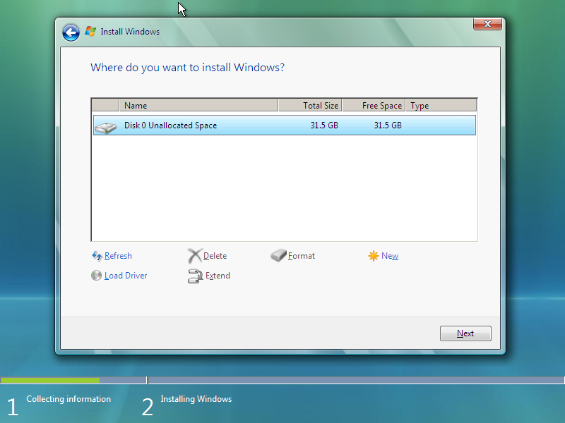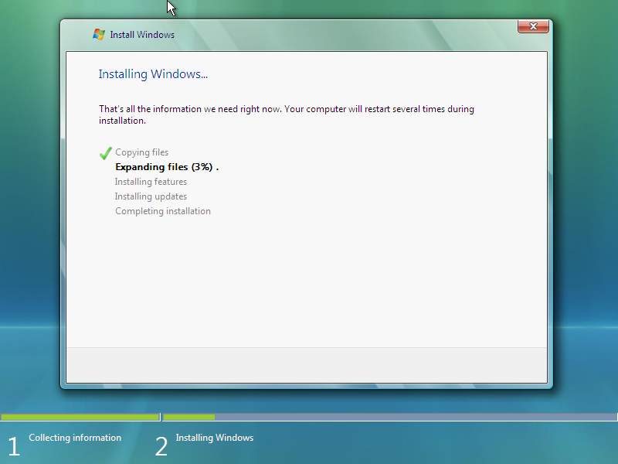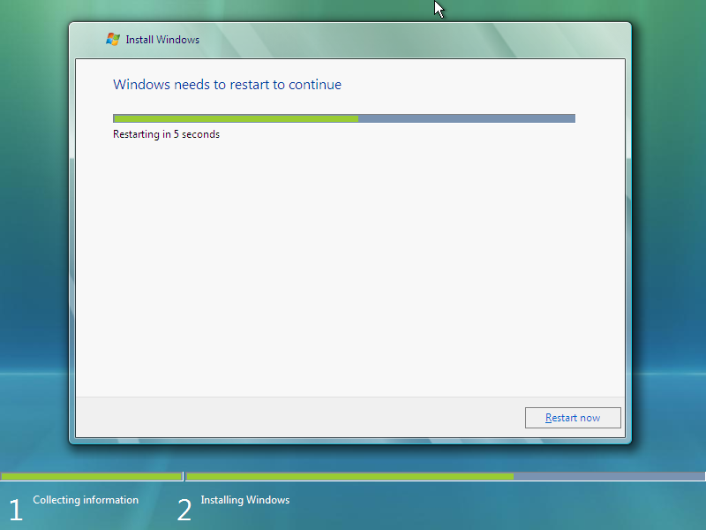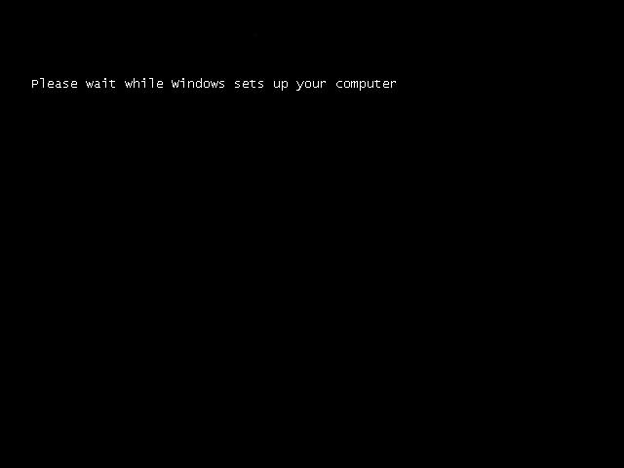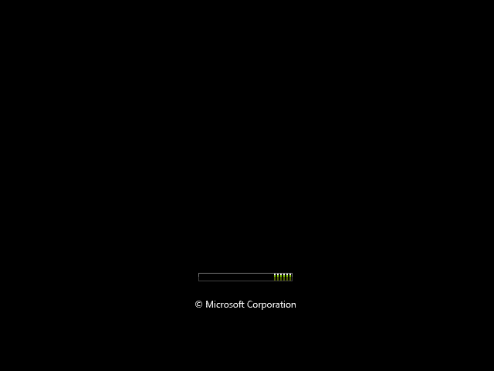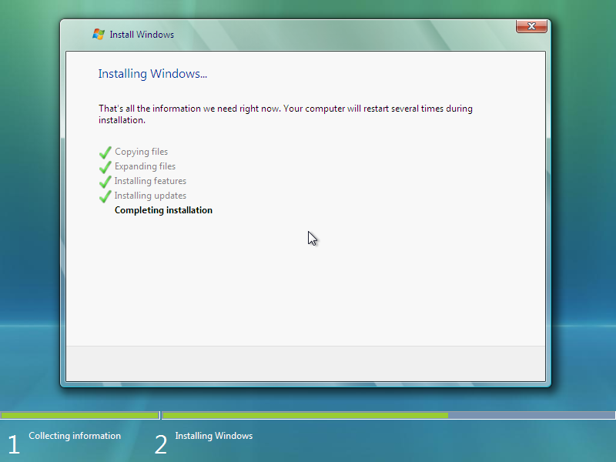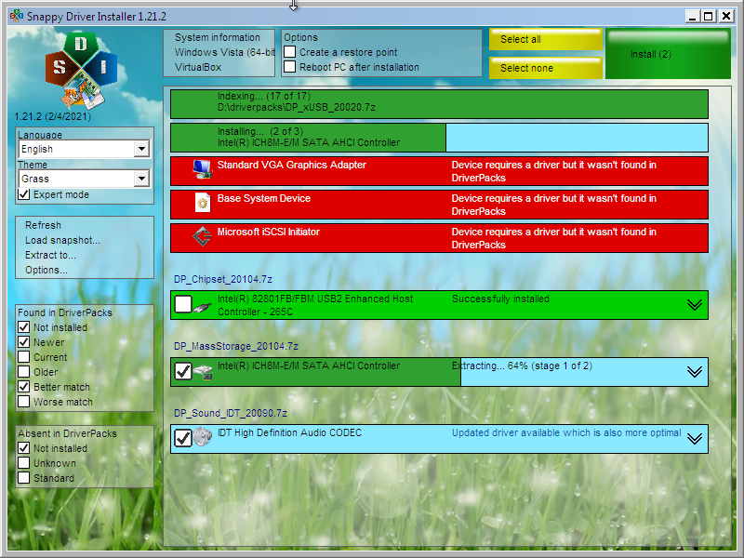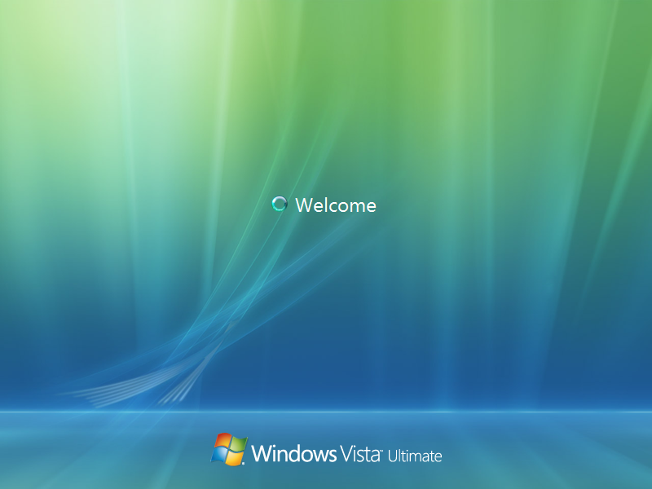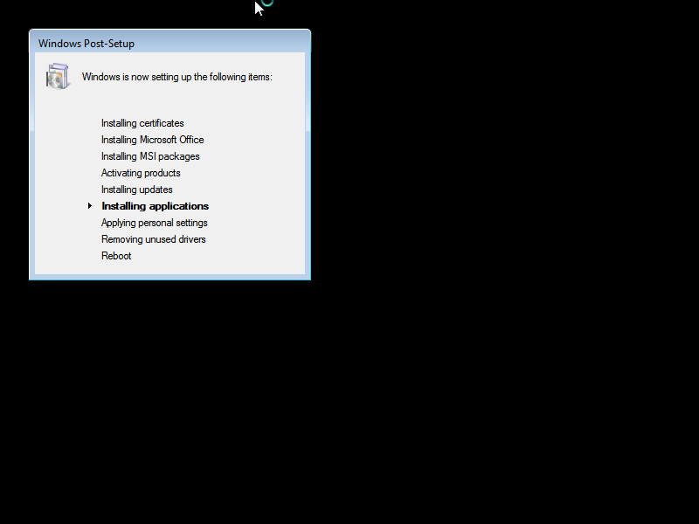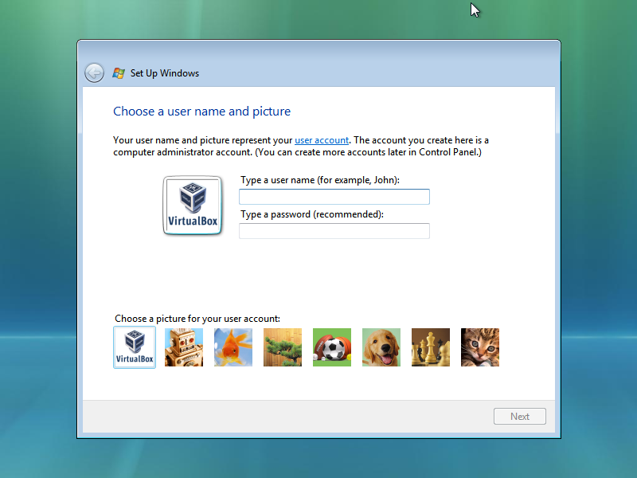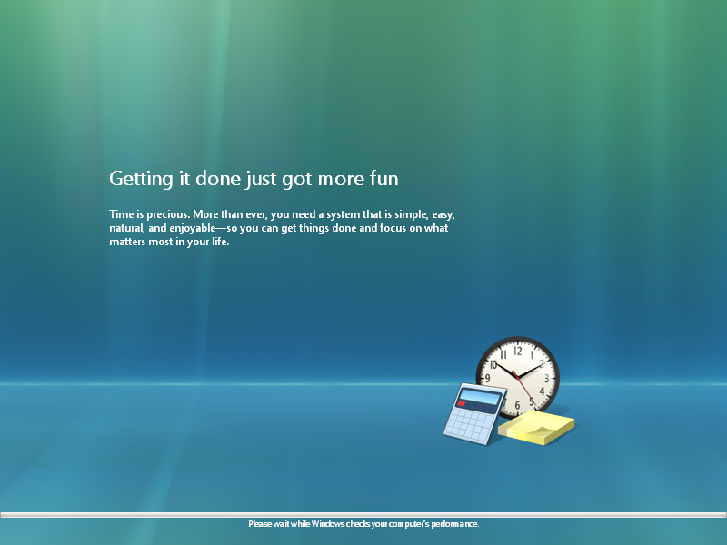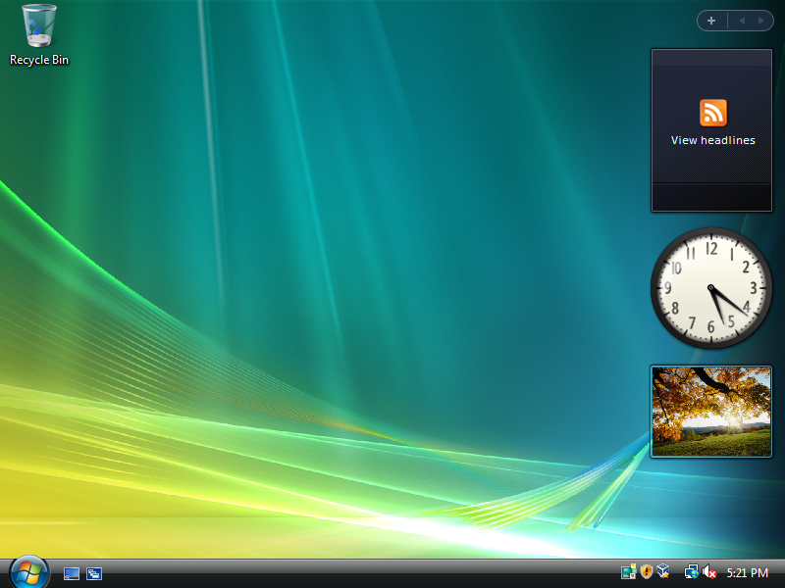

**Windows 7 with POWIS**

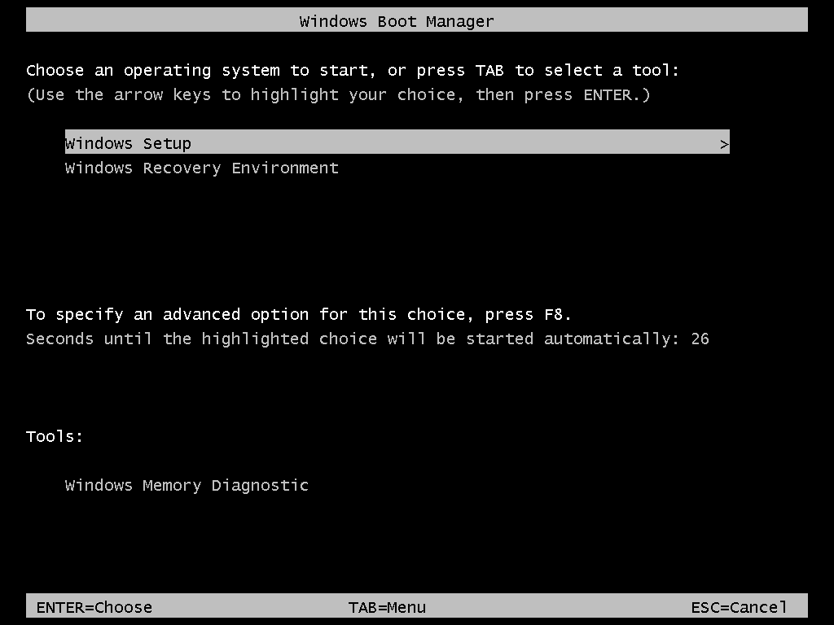

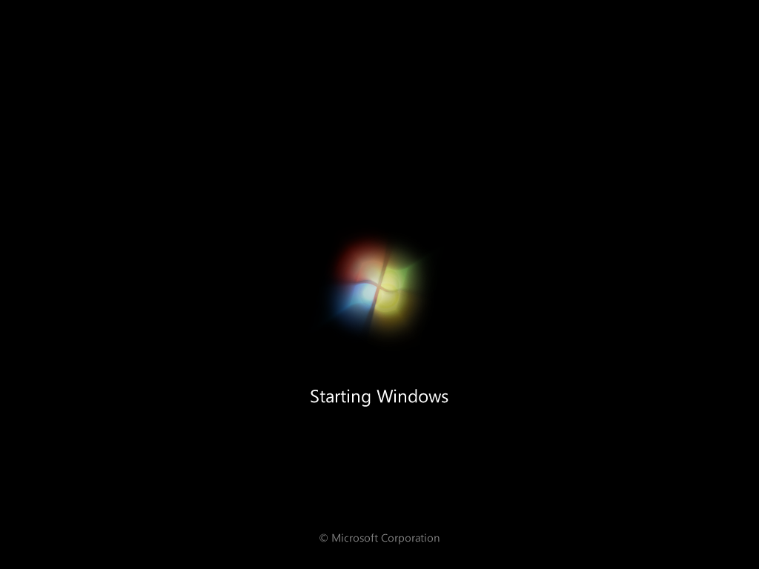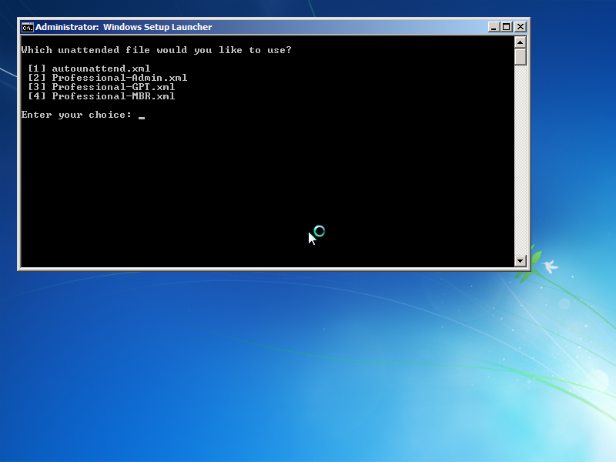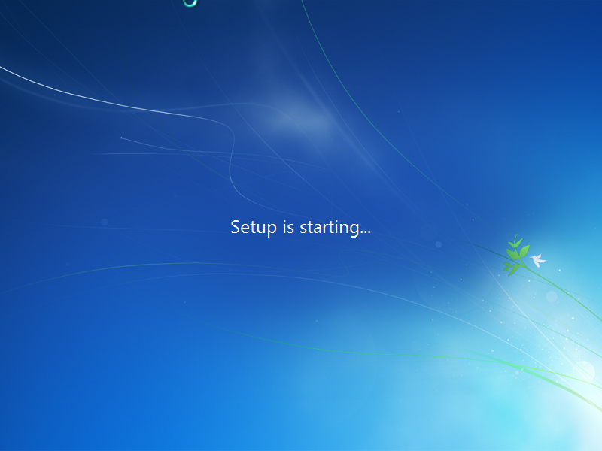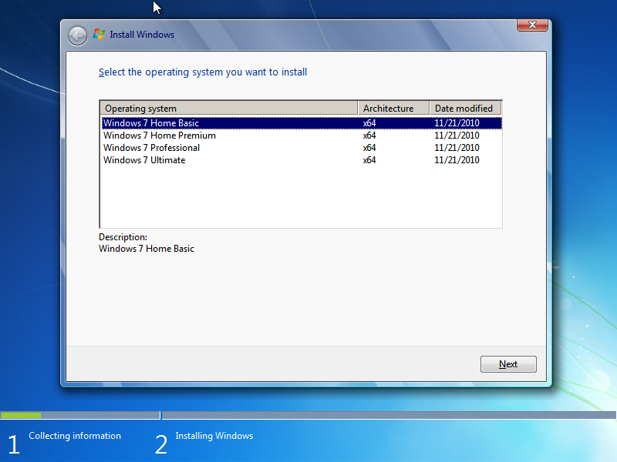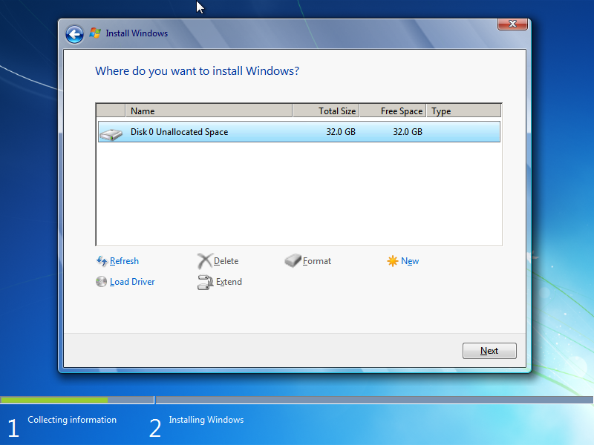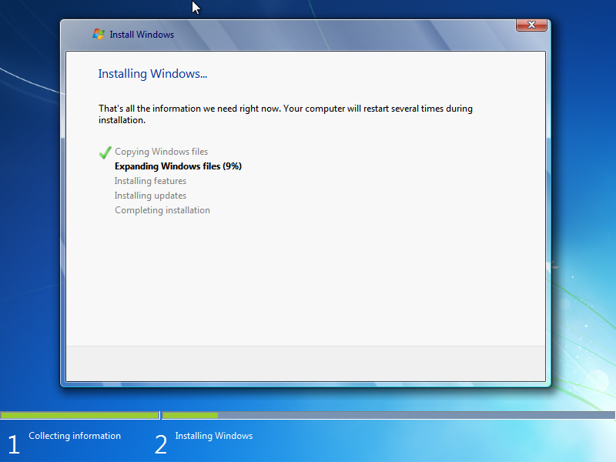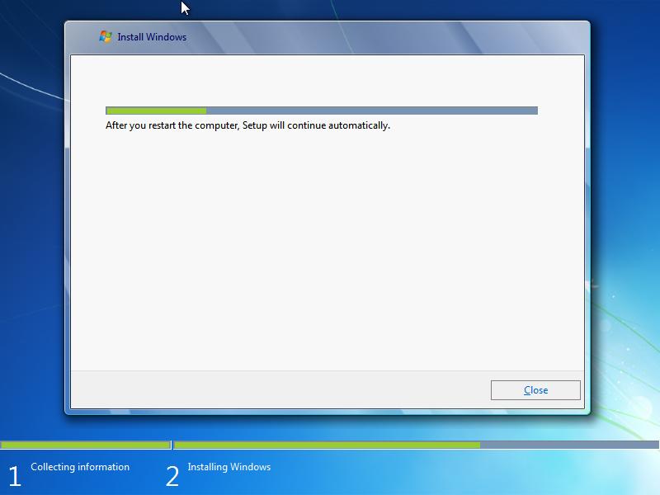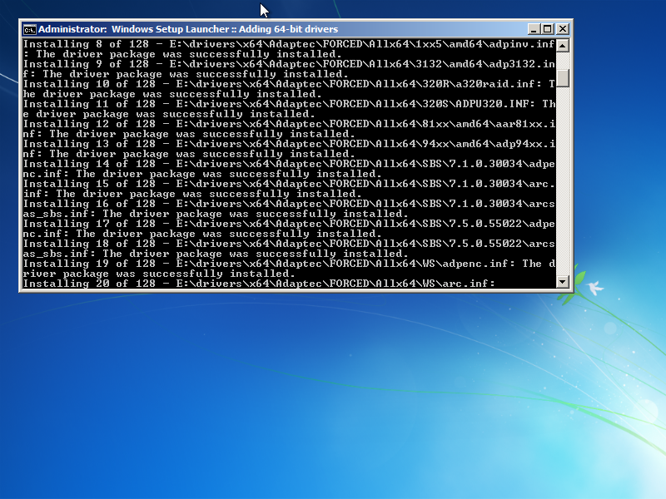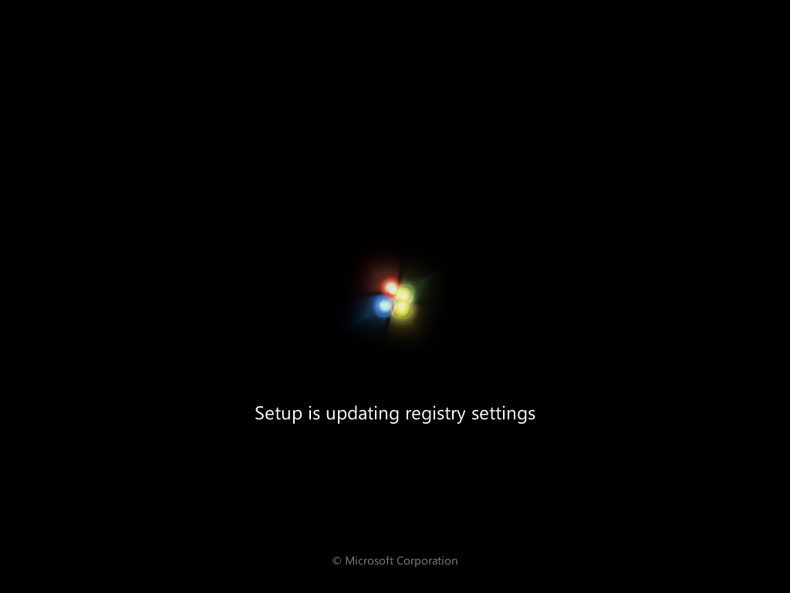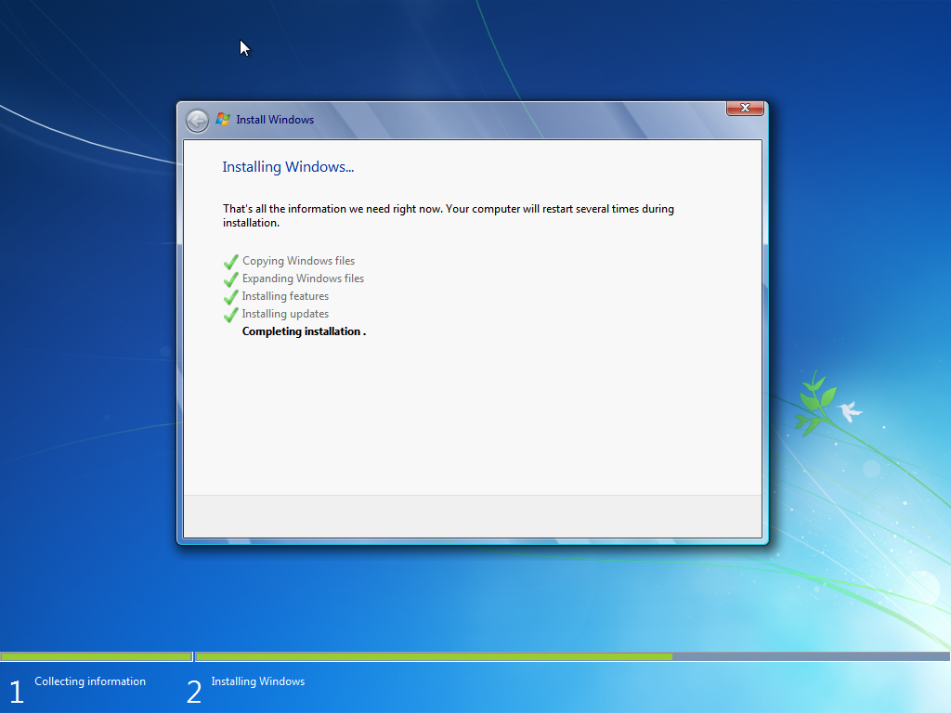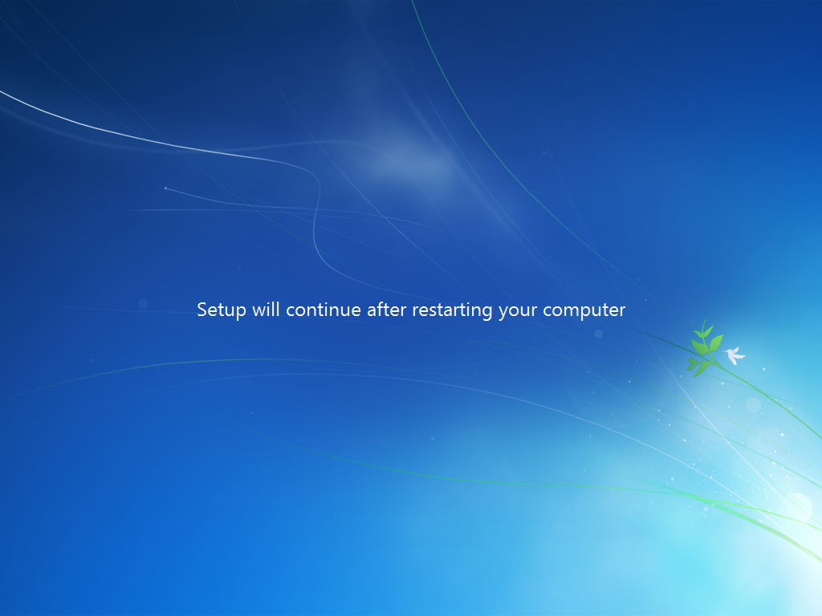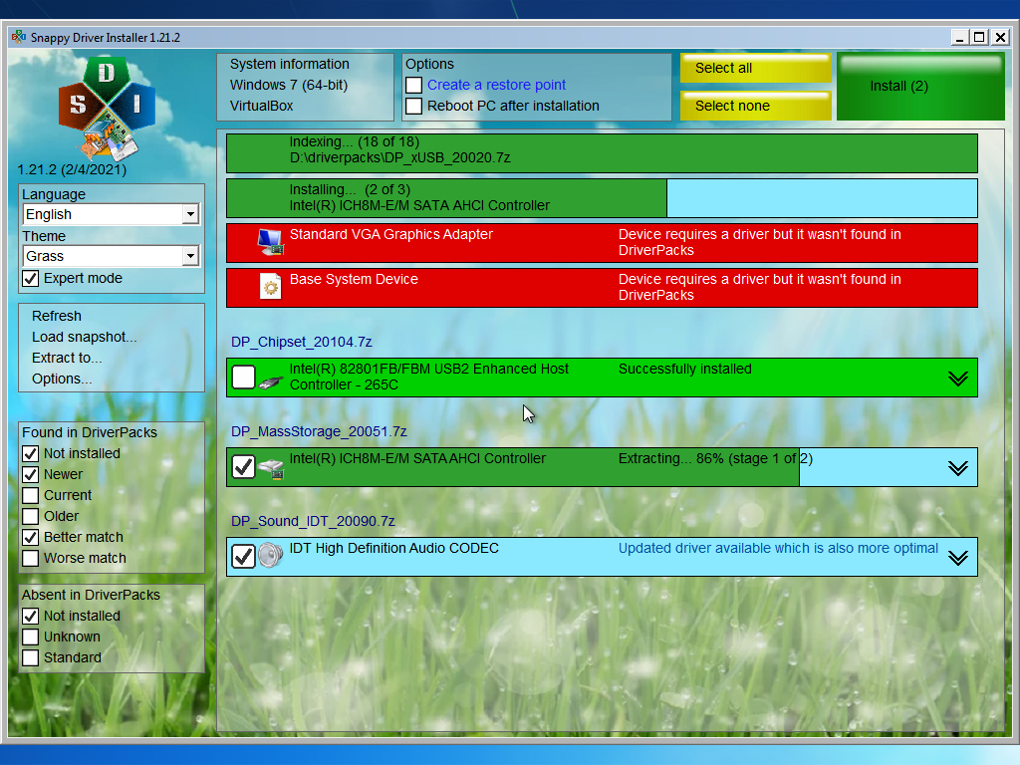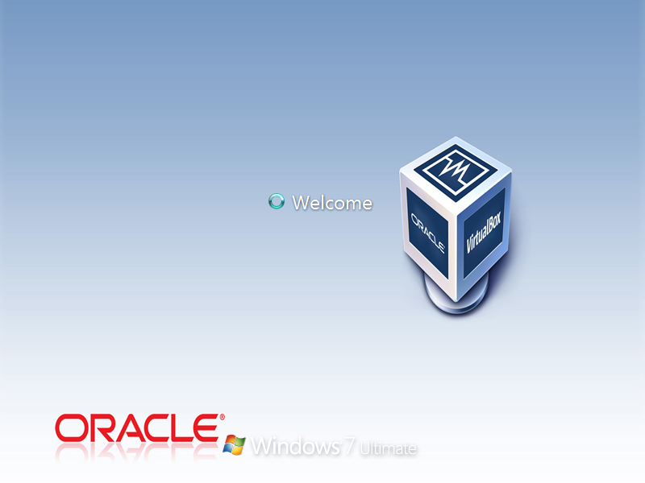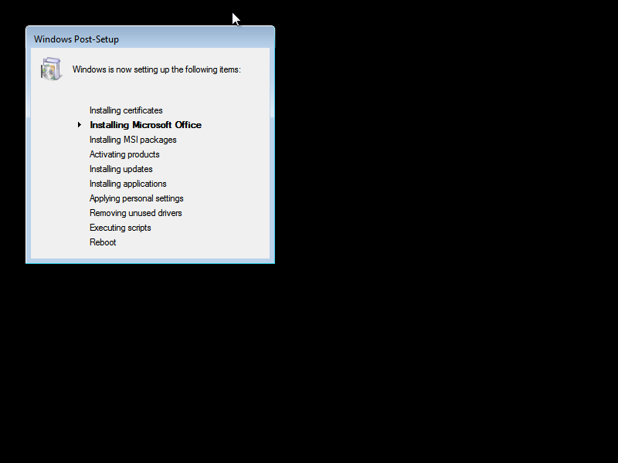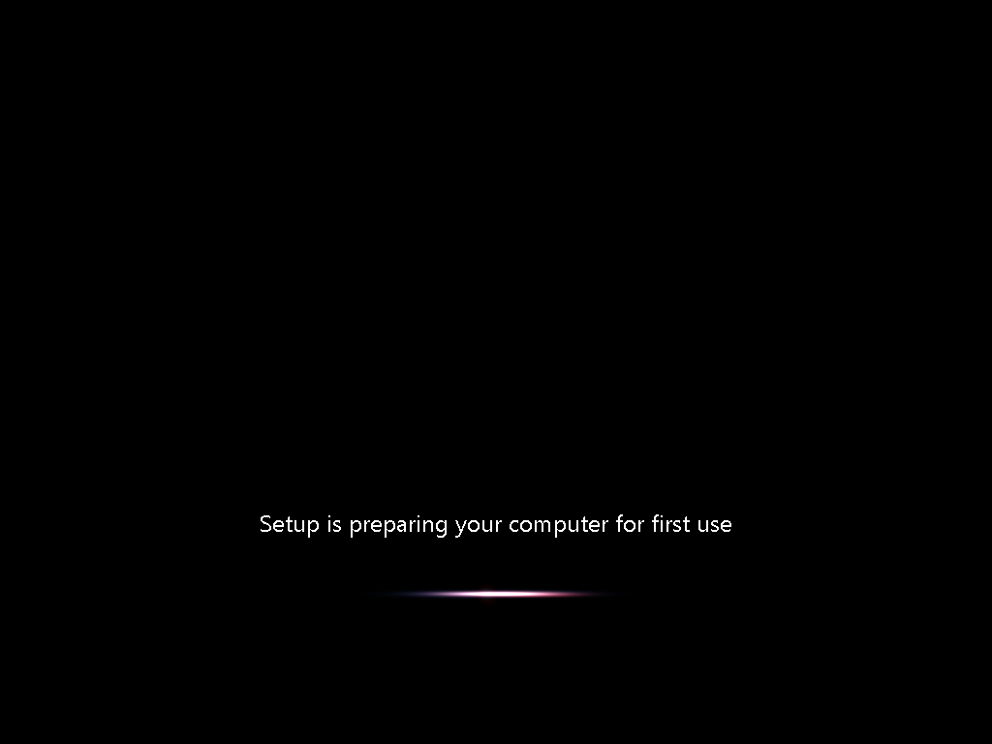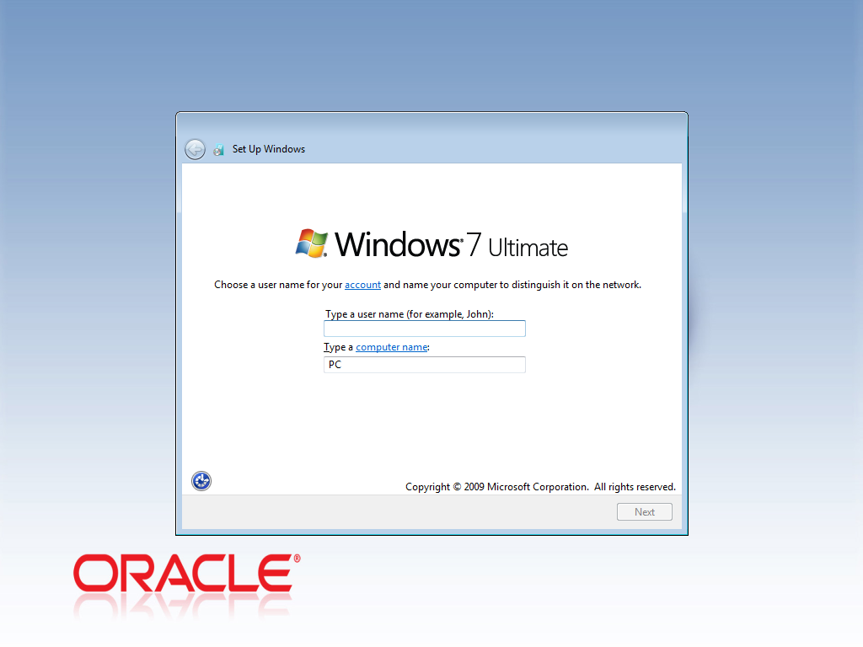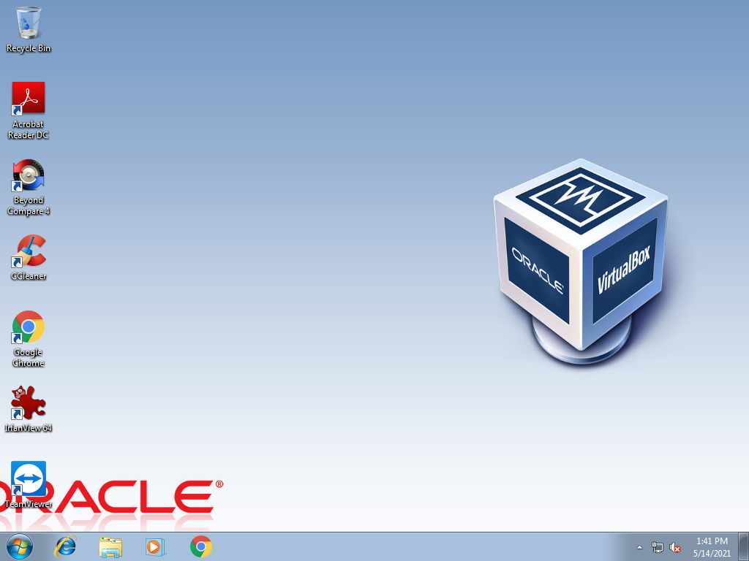

**Windows 8 with POWIS**

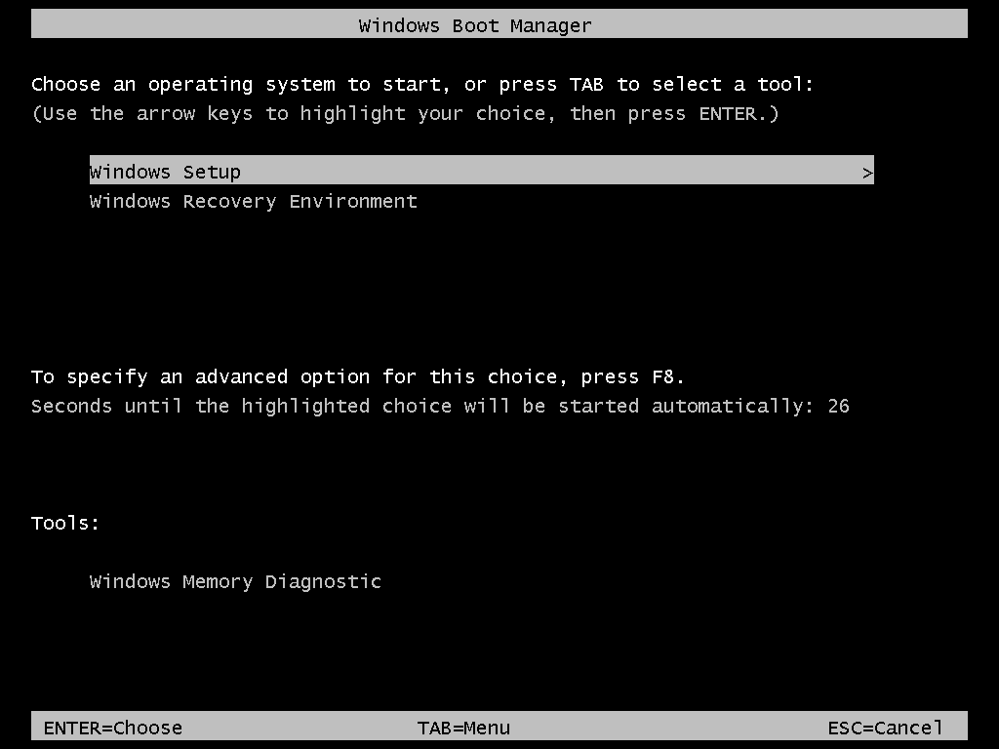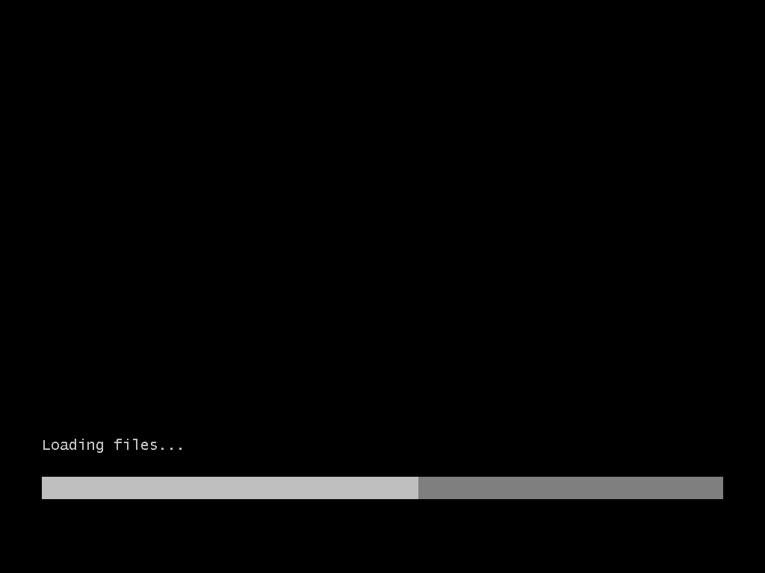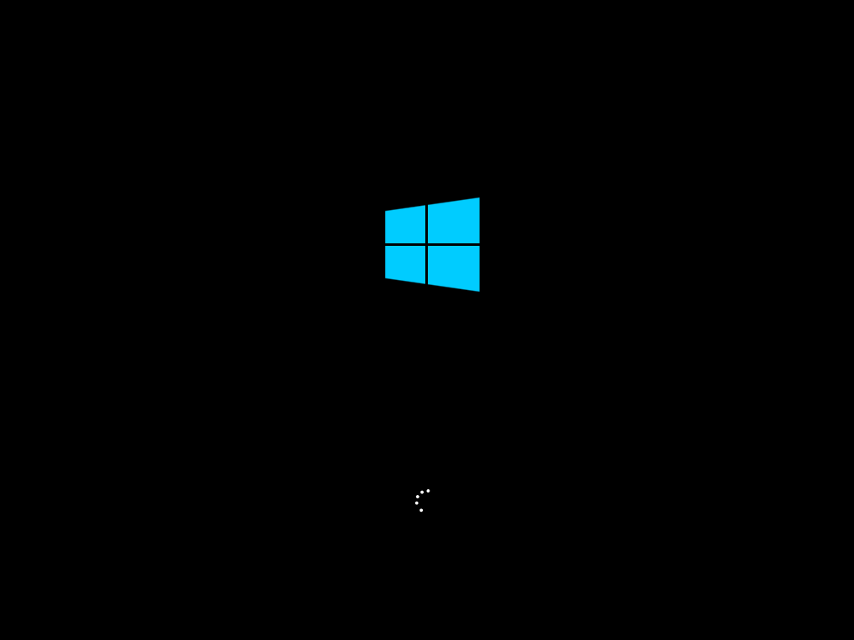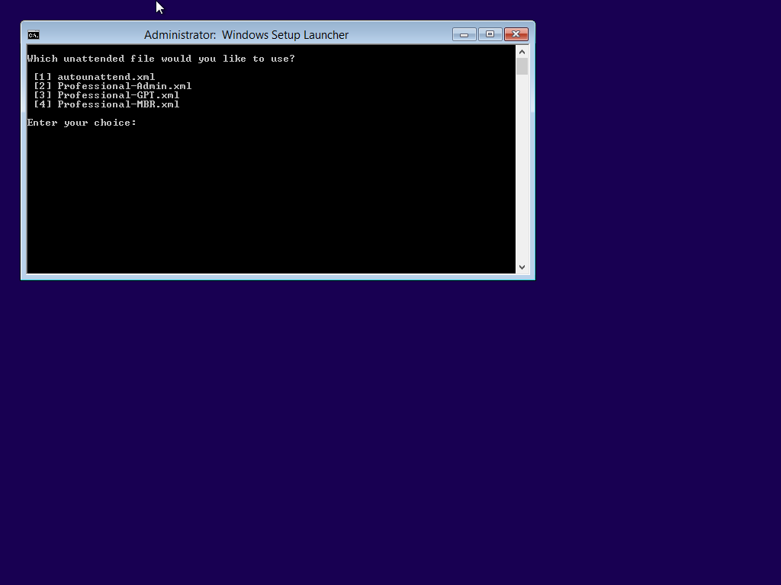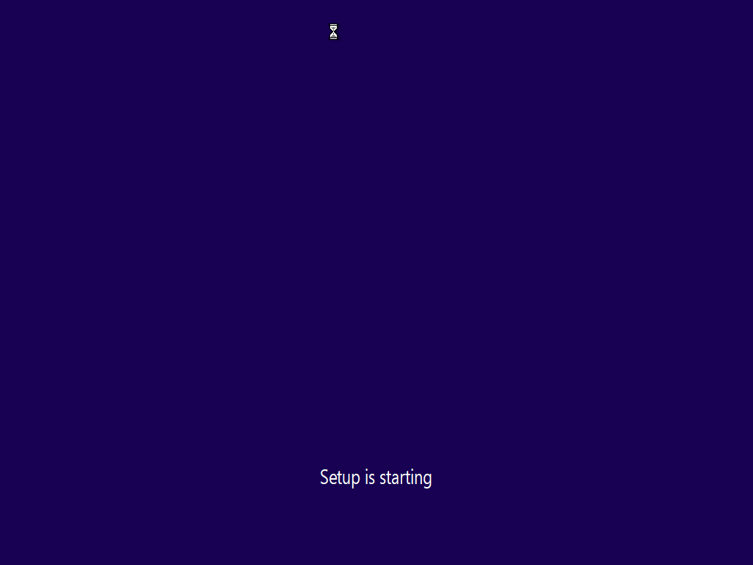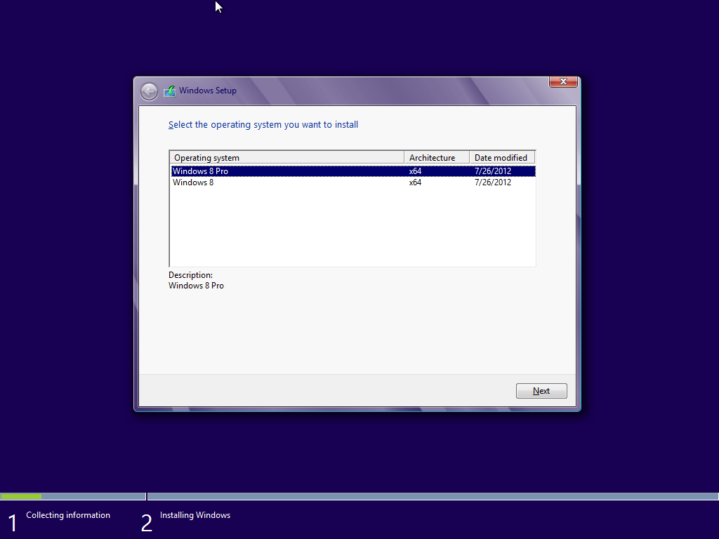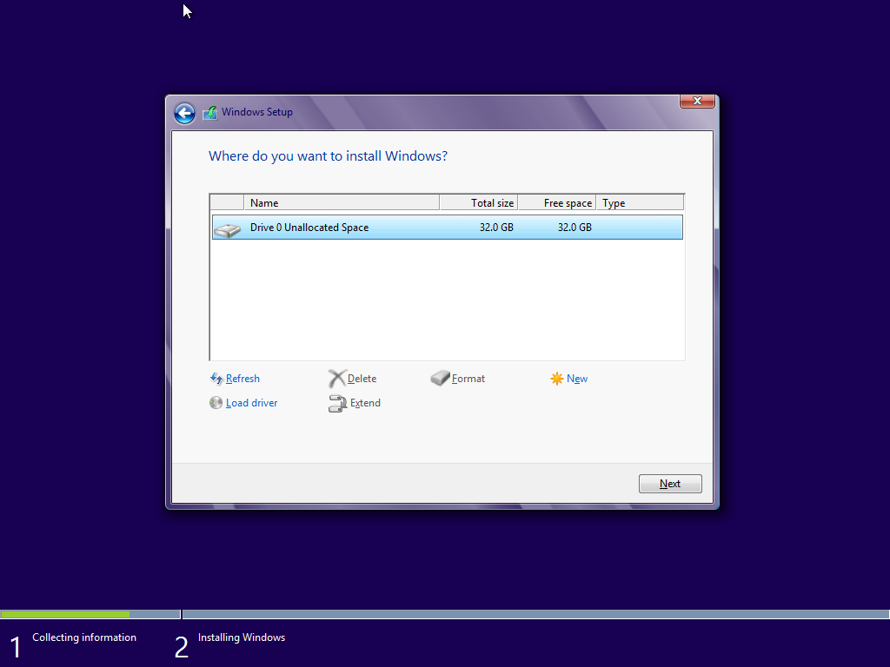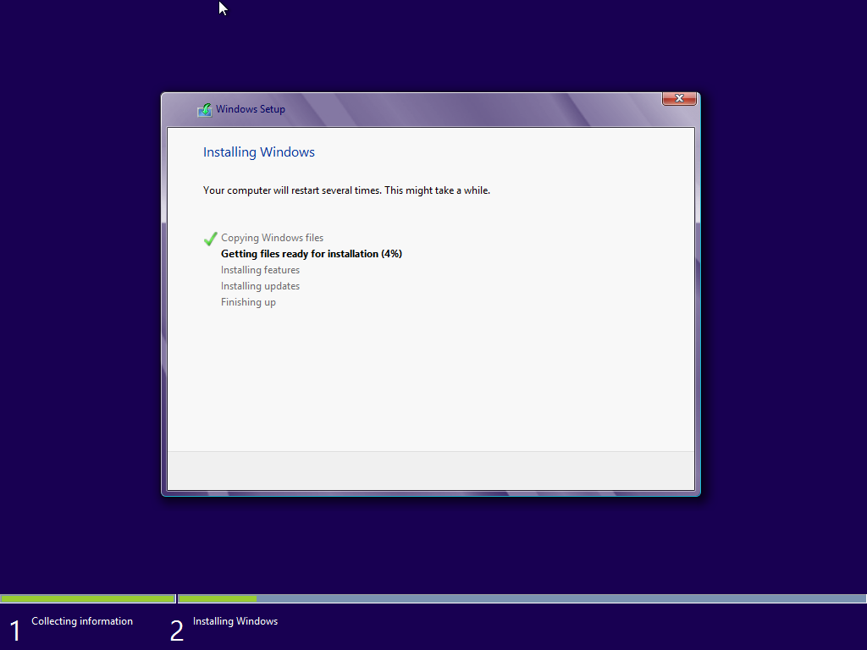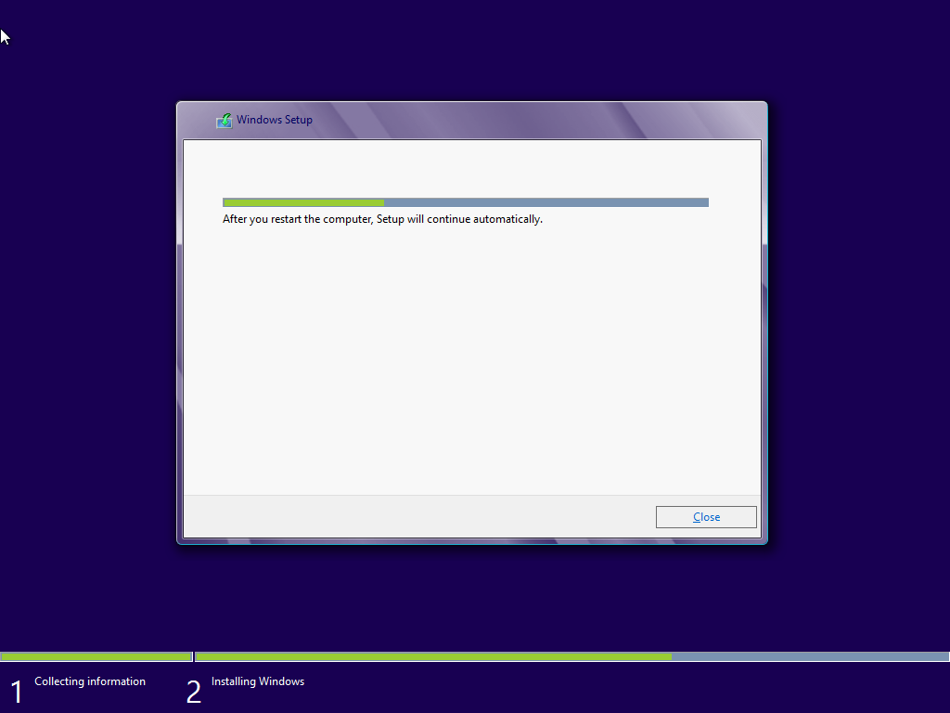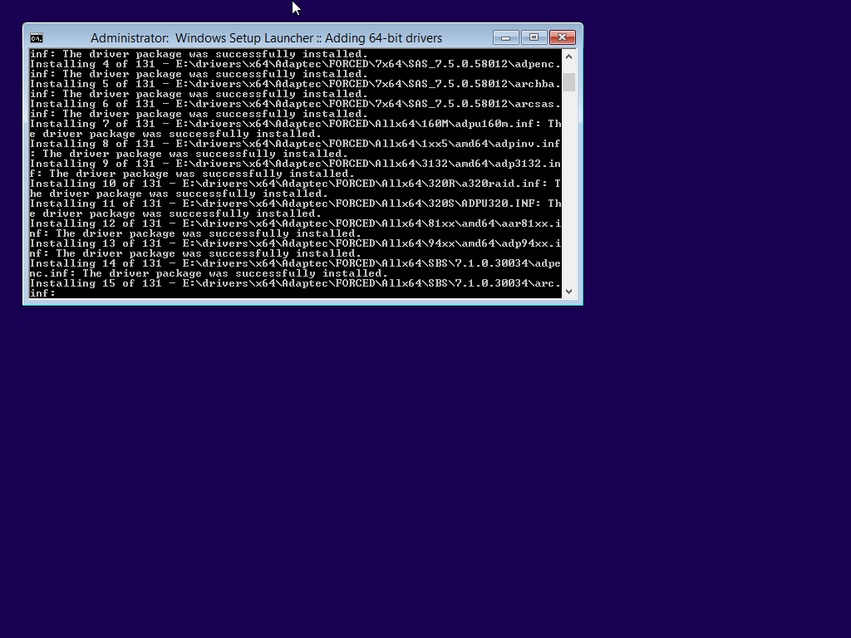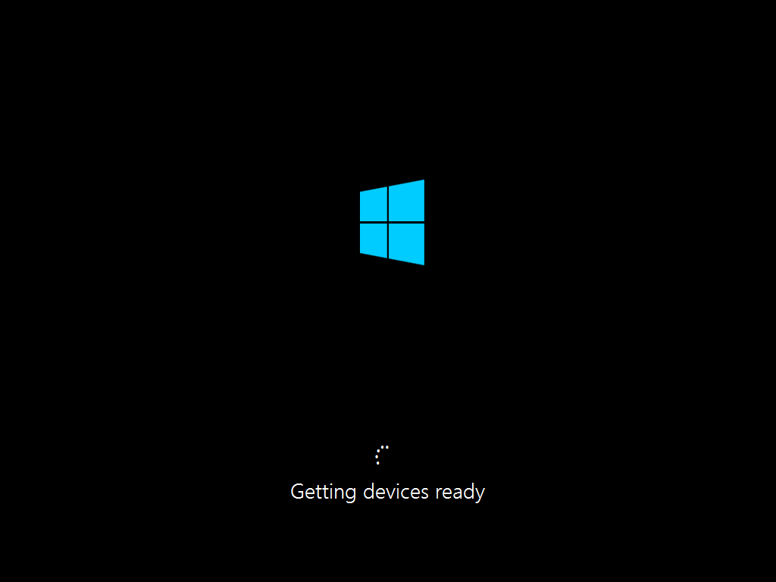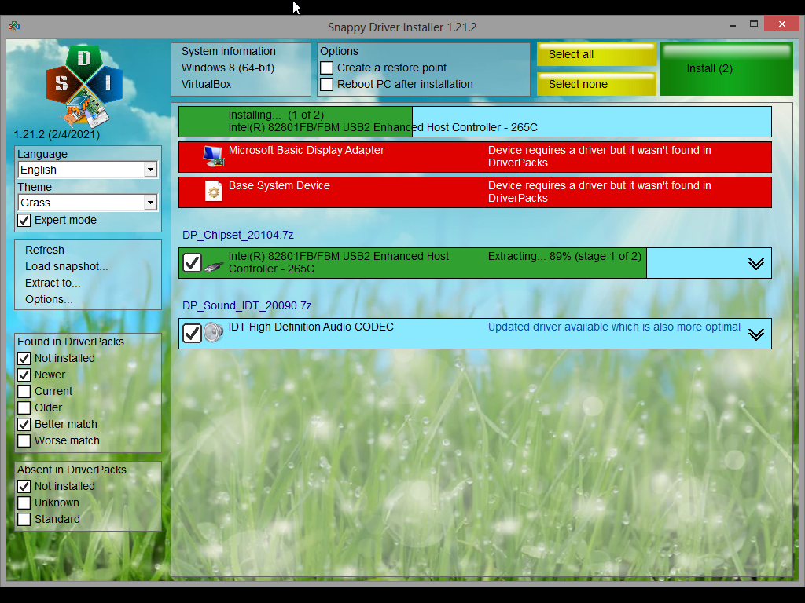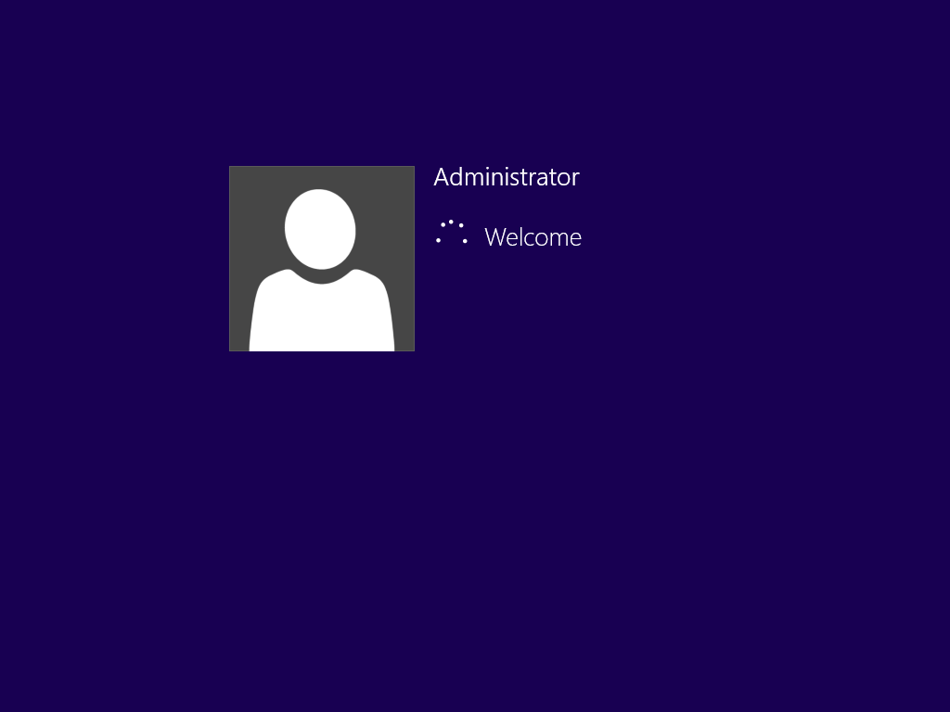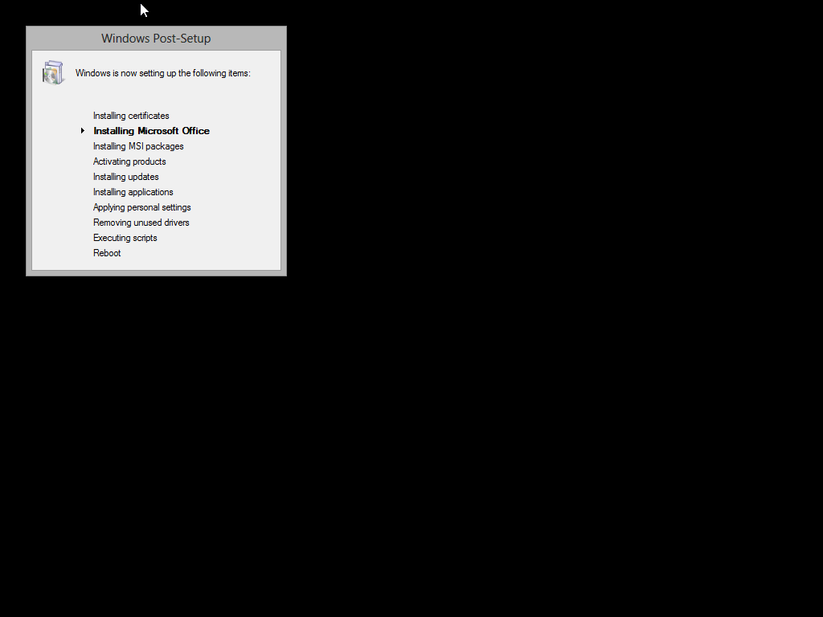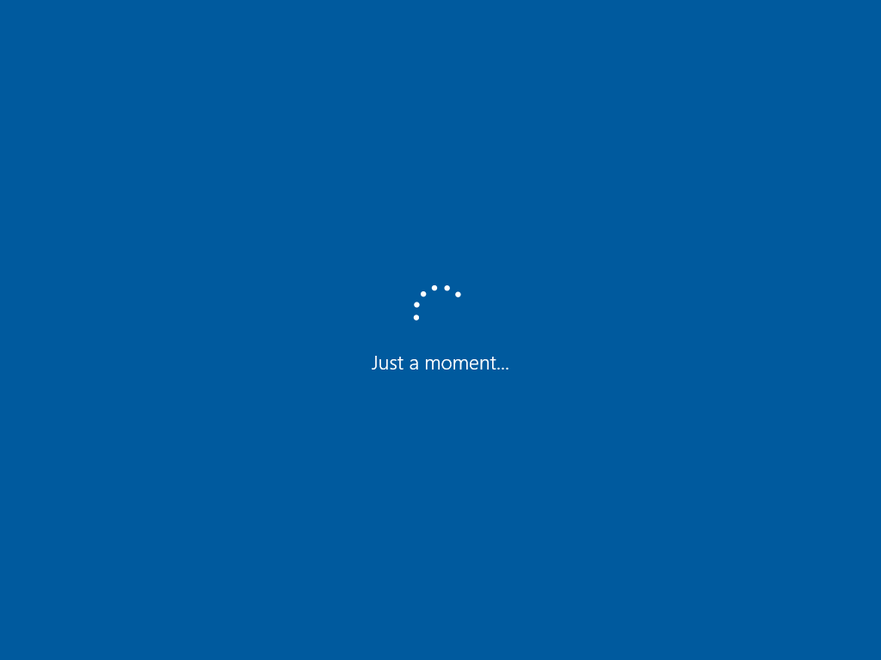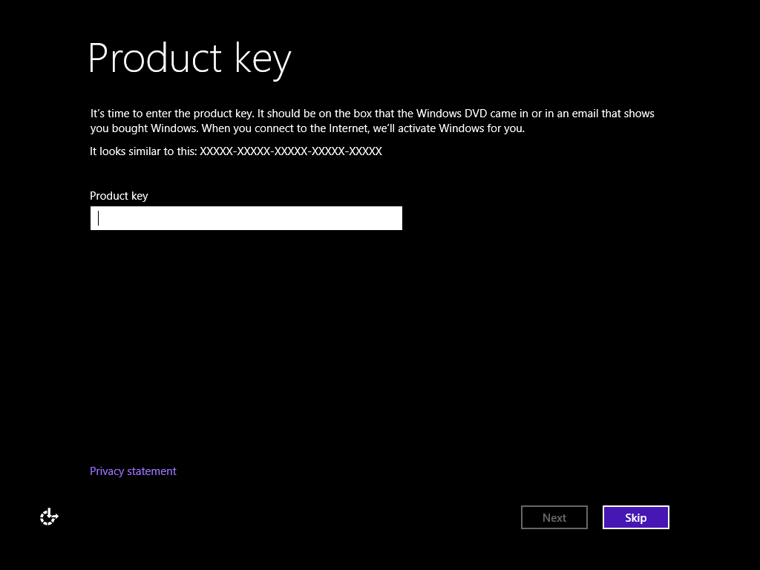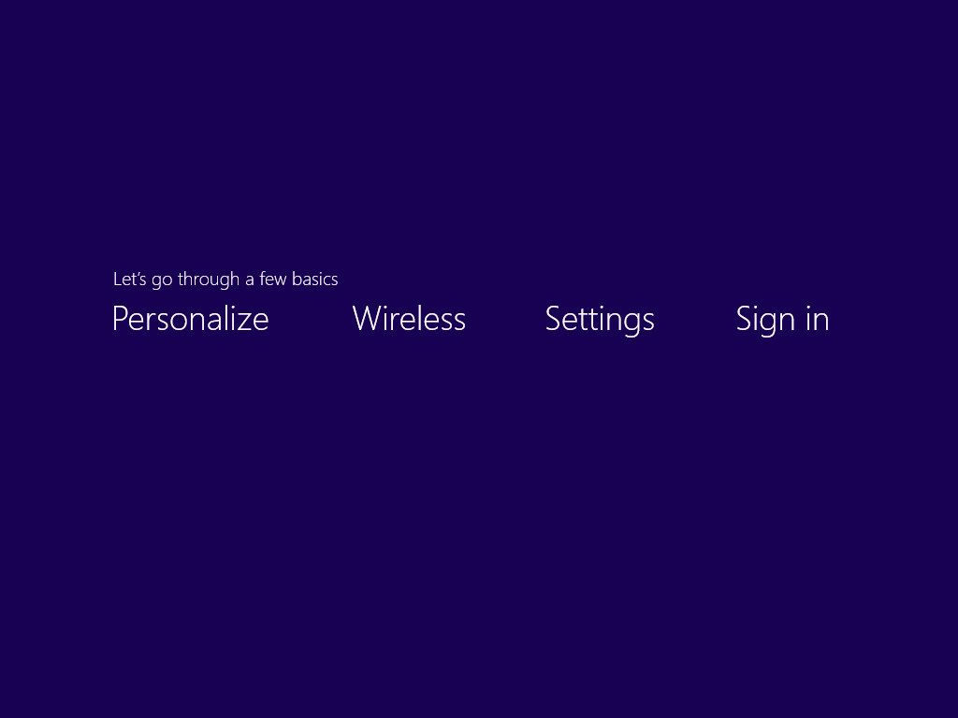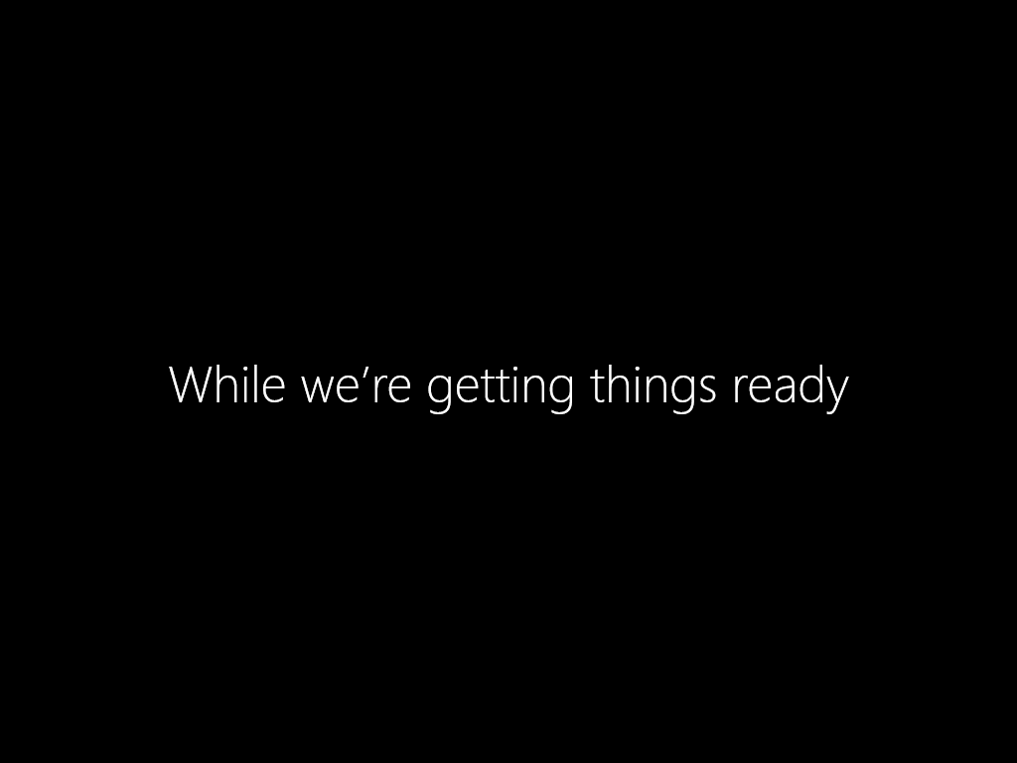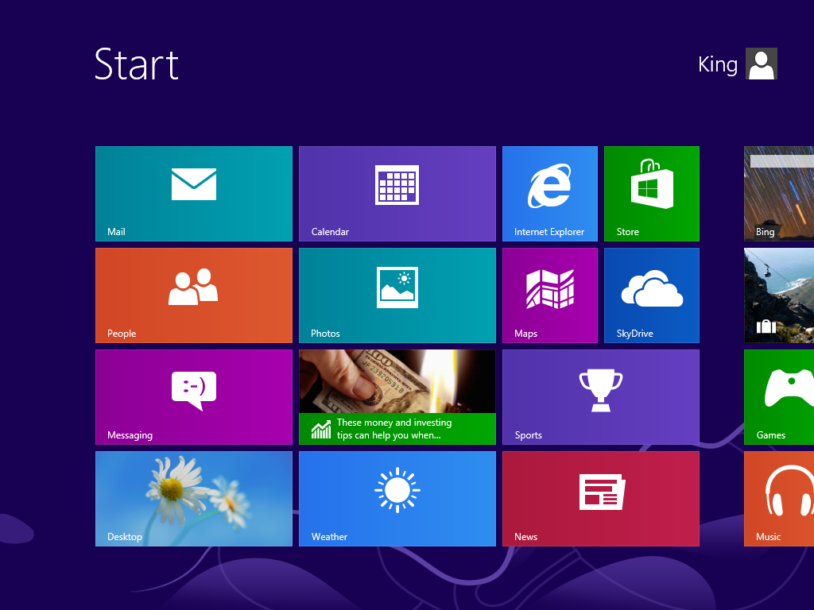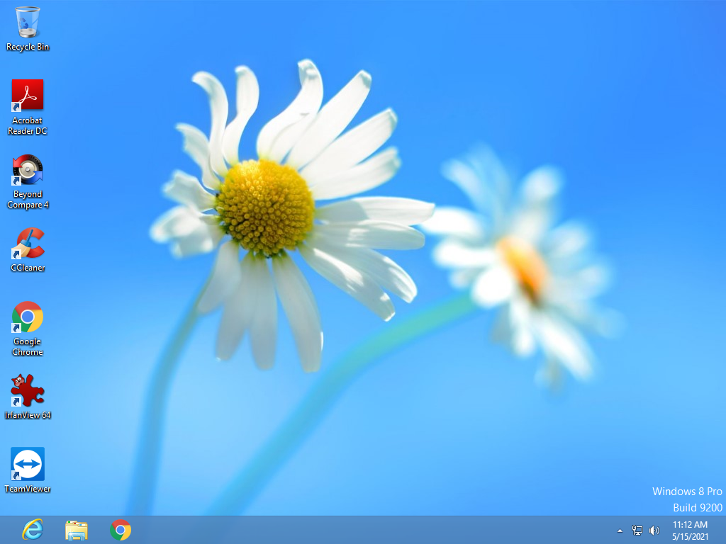

**Windows 8.1 with POWIS**

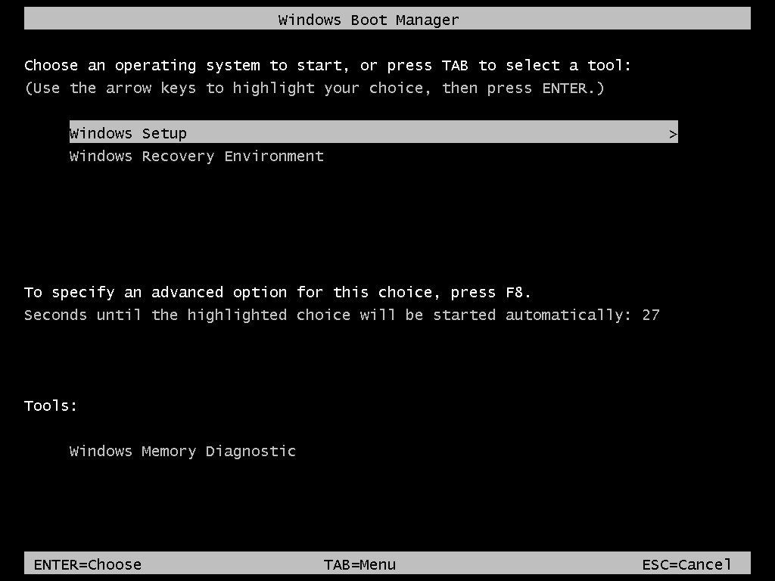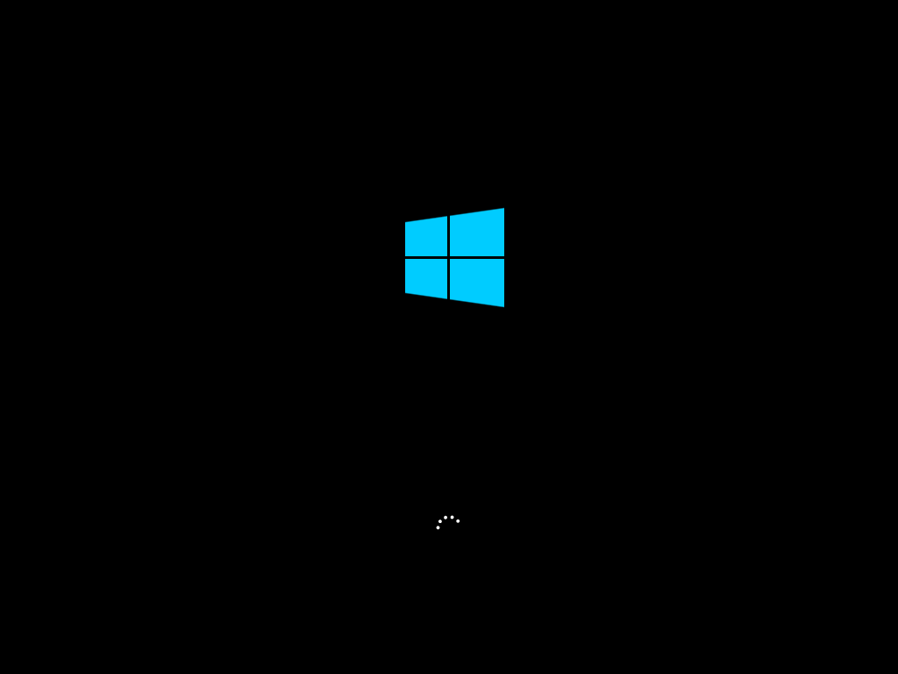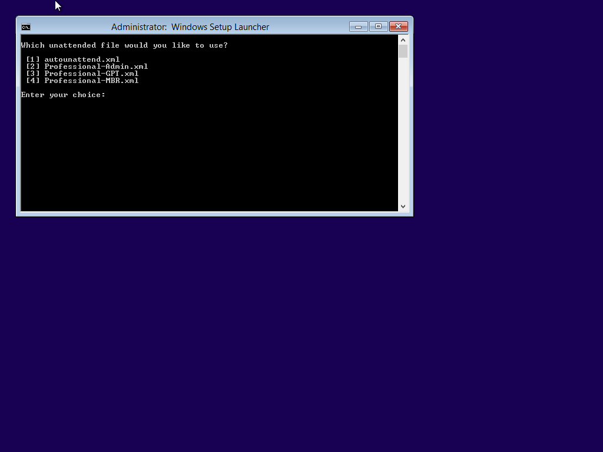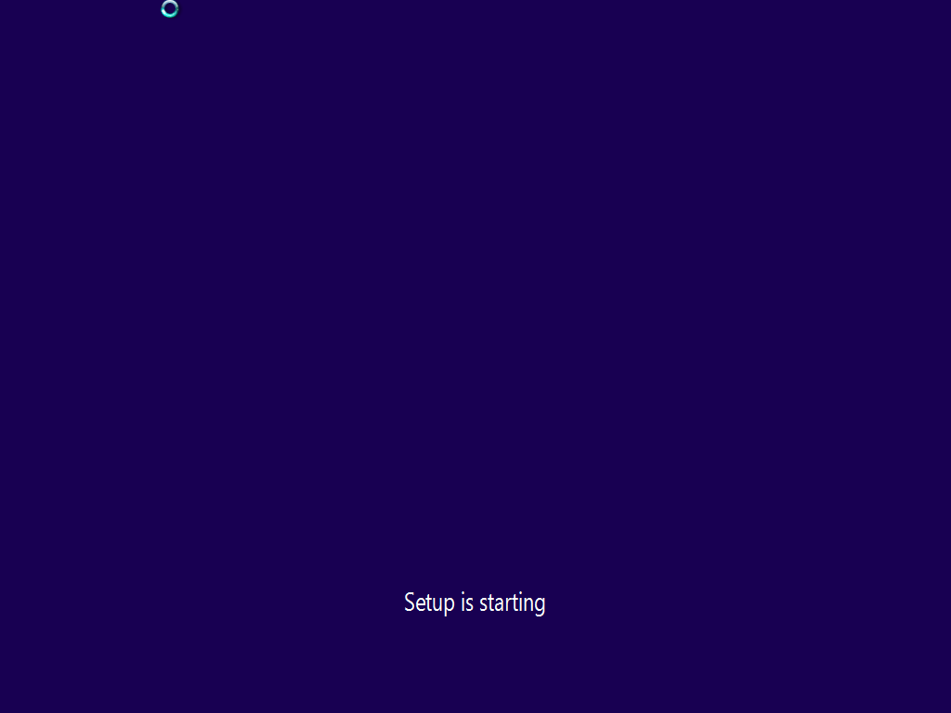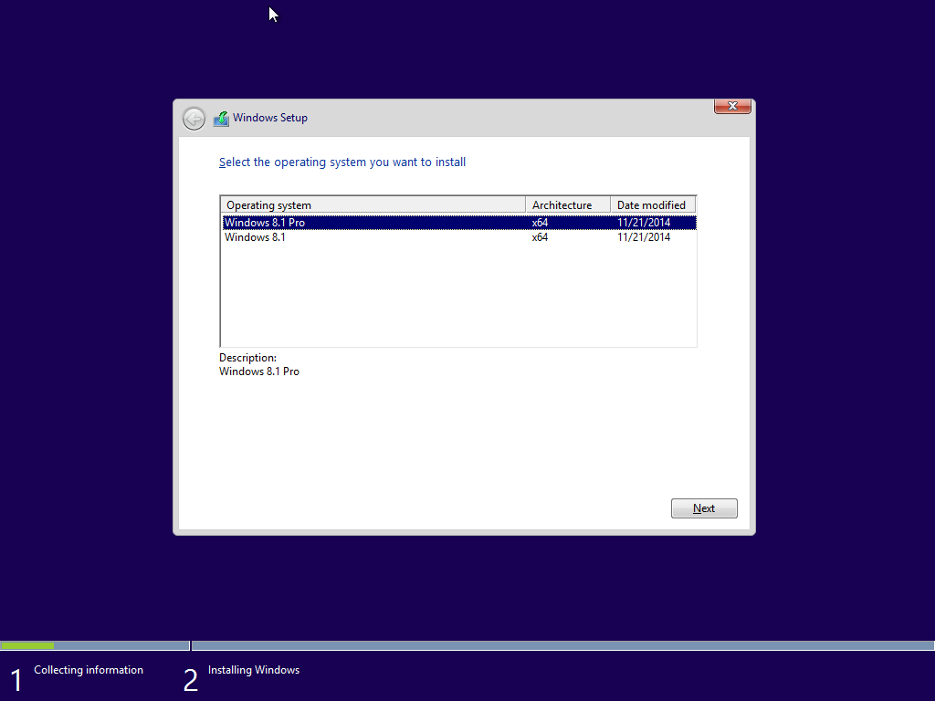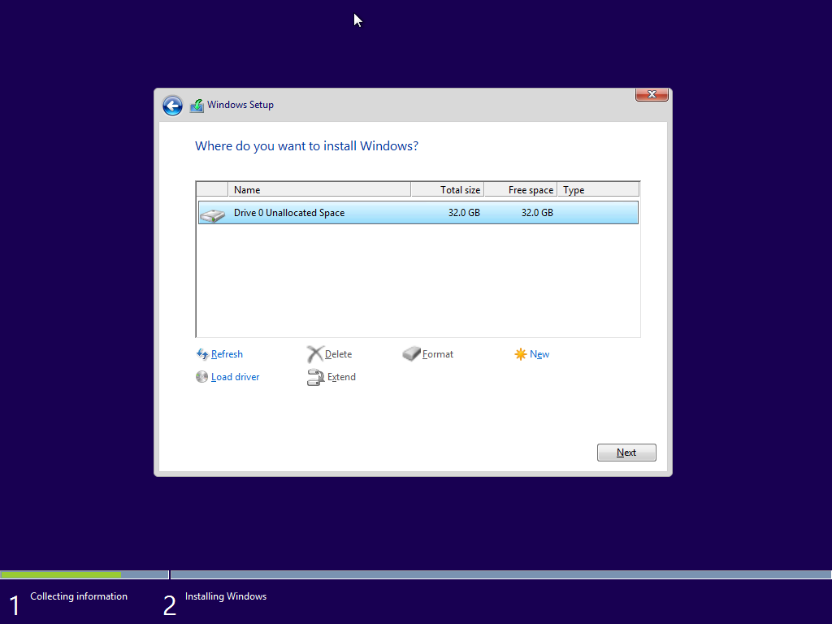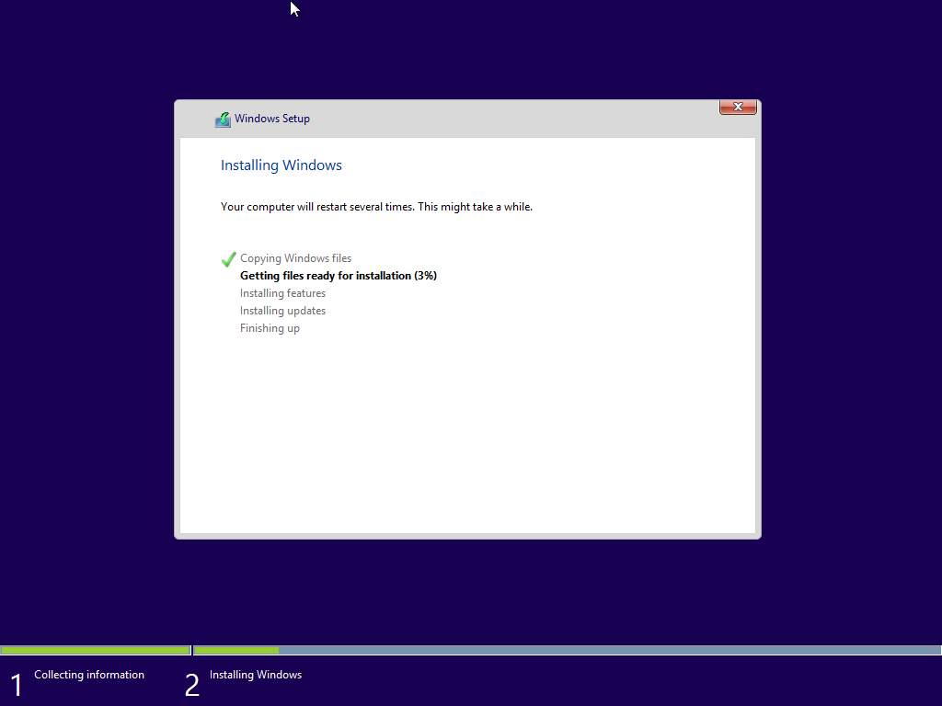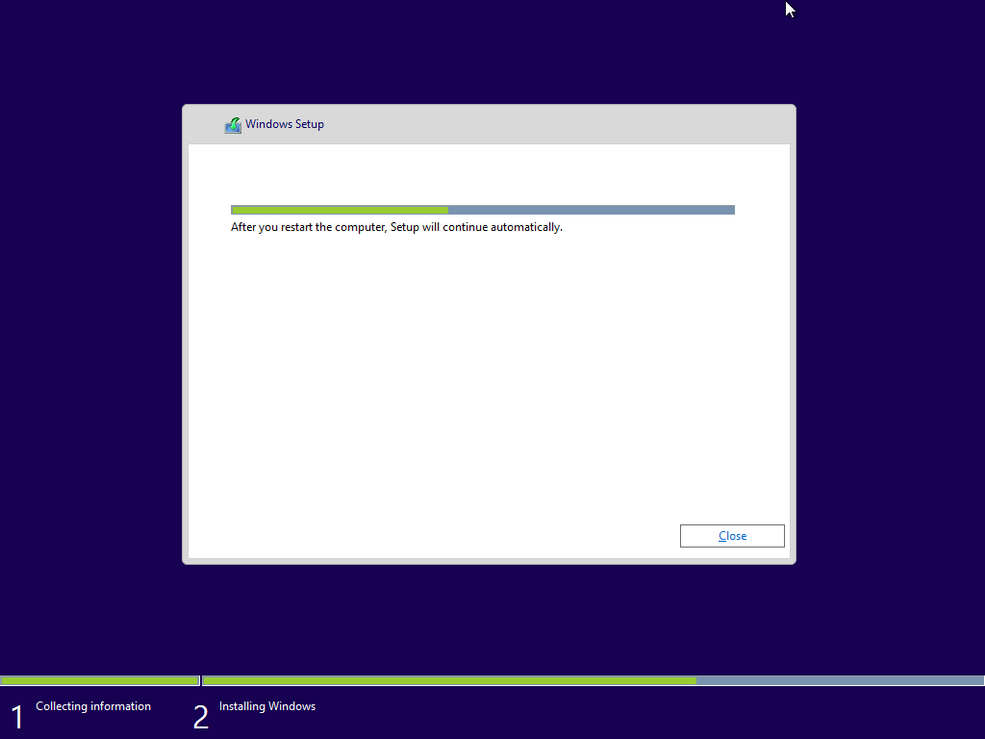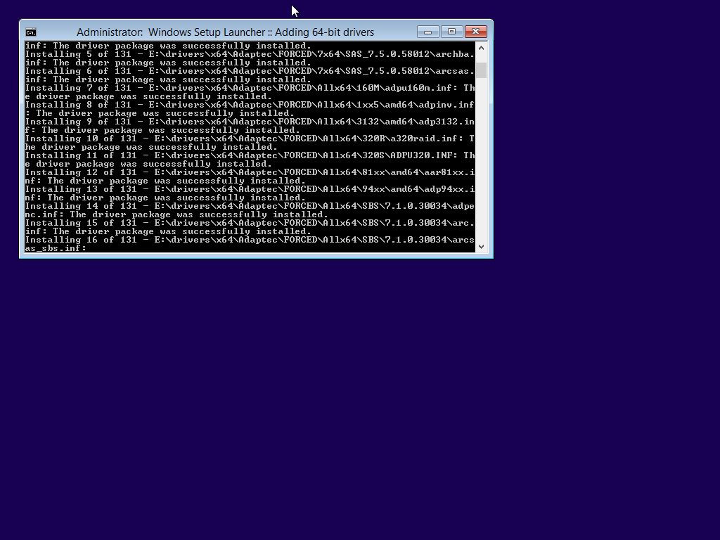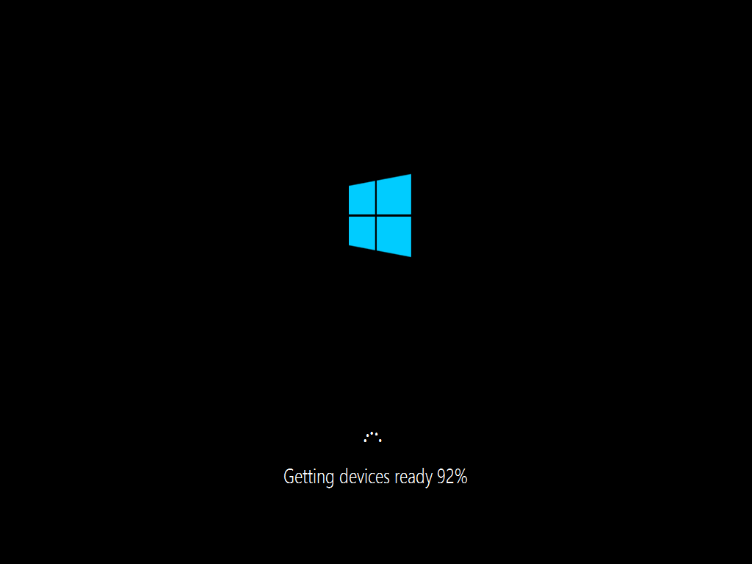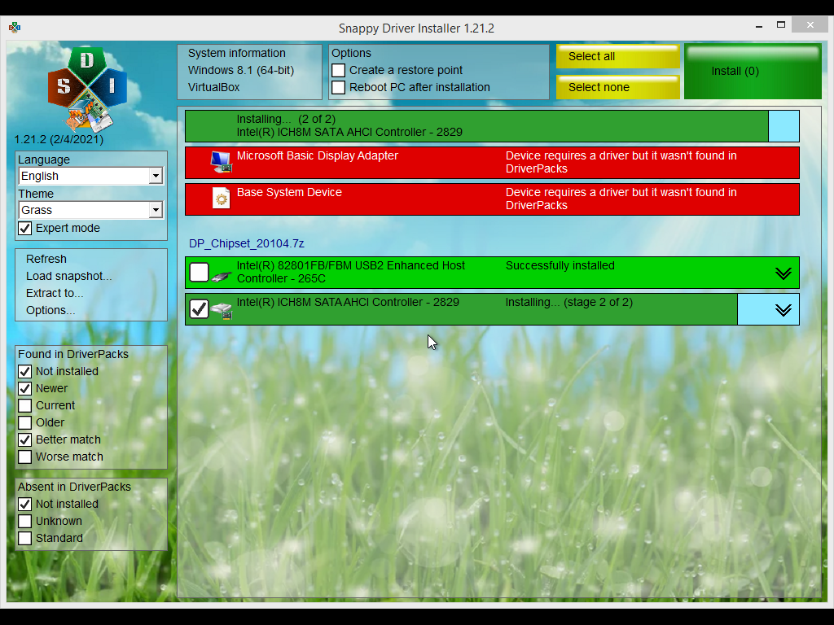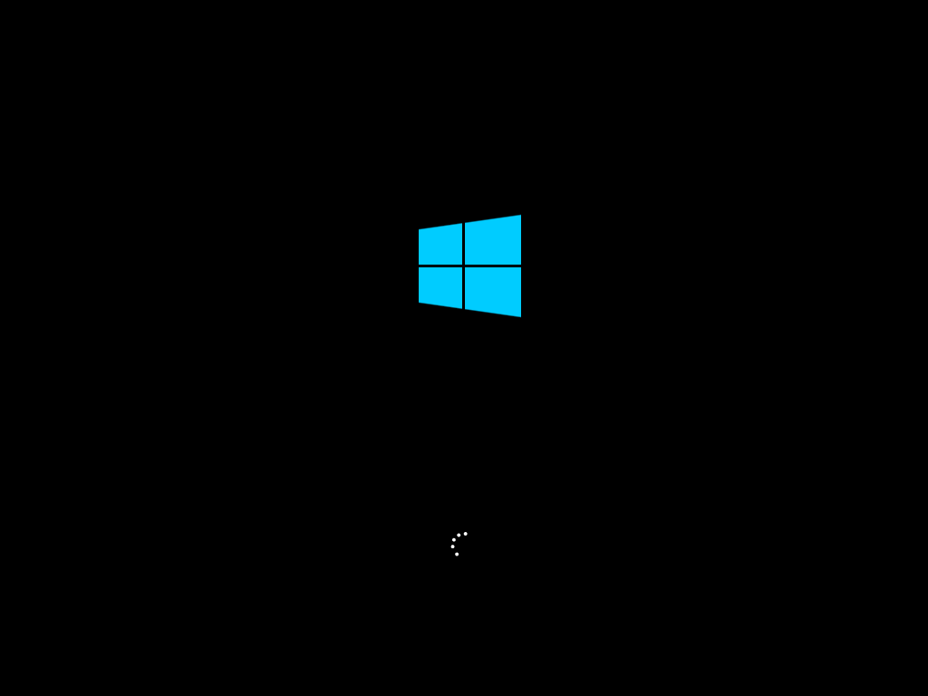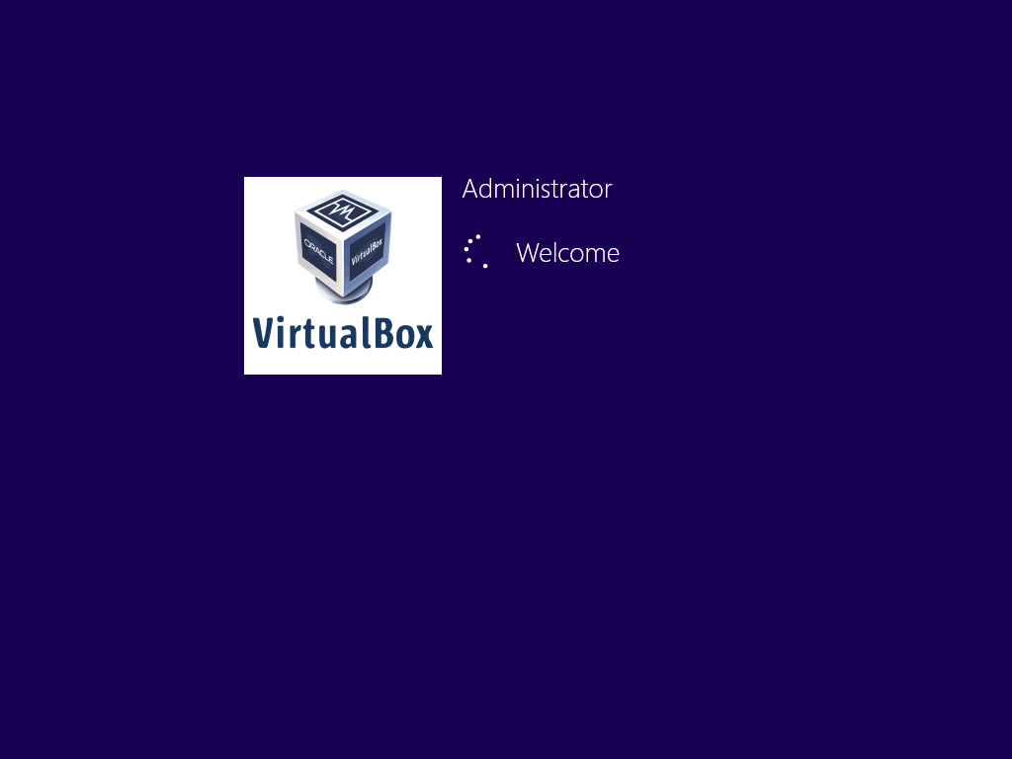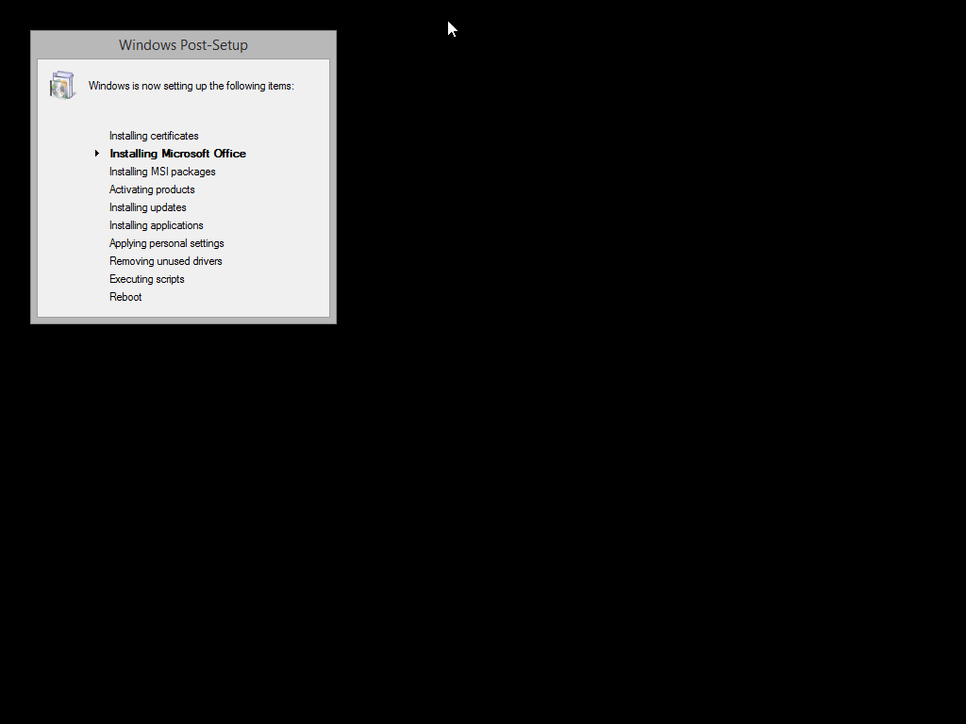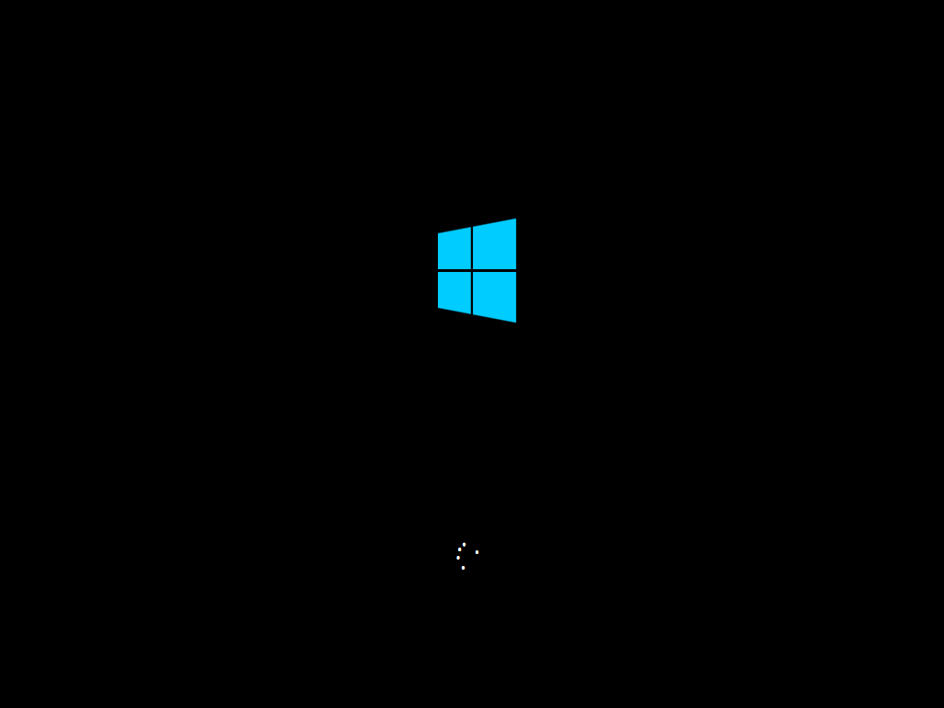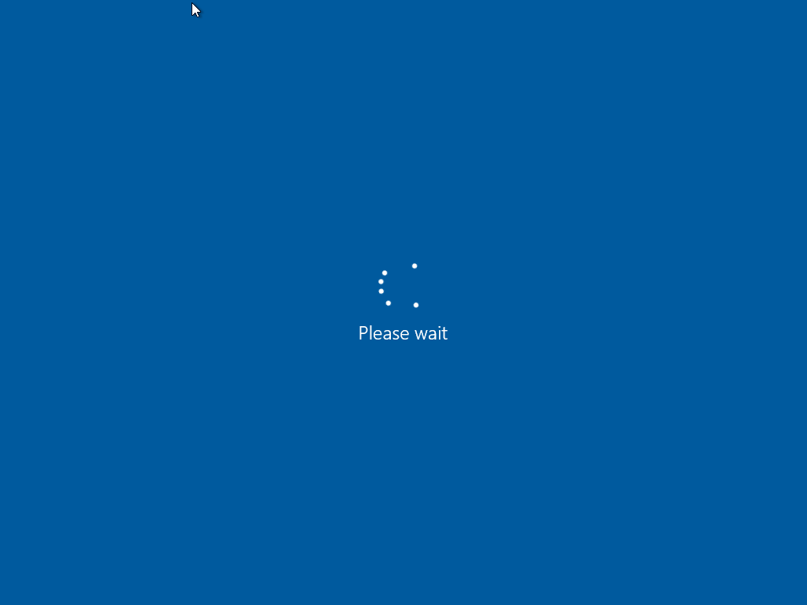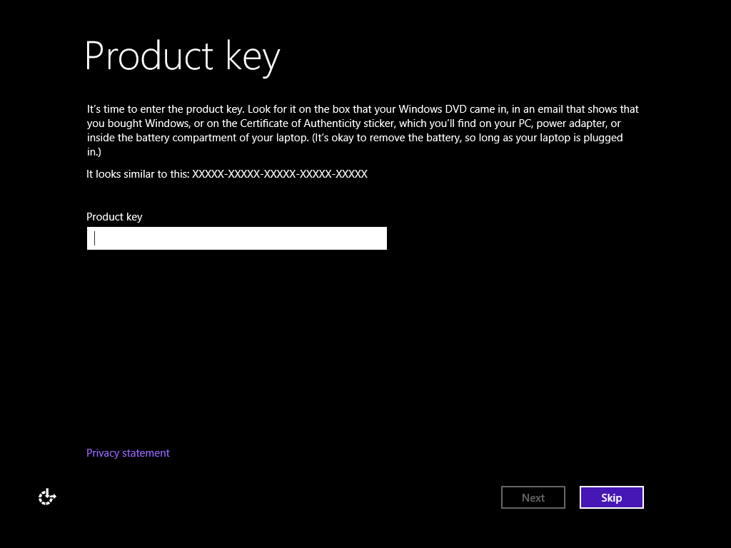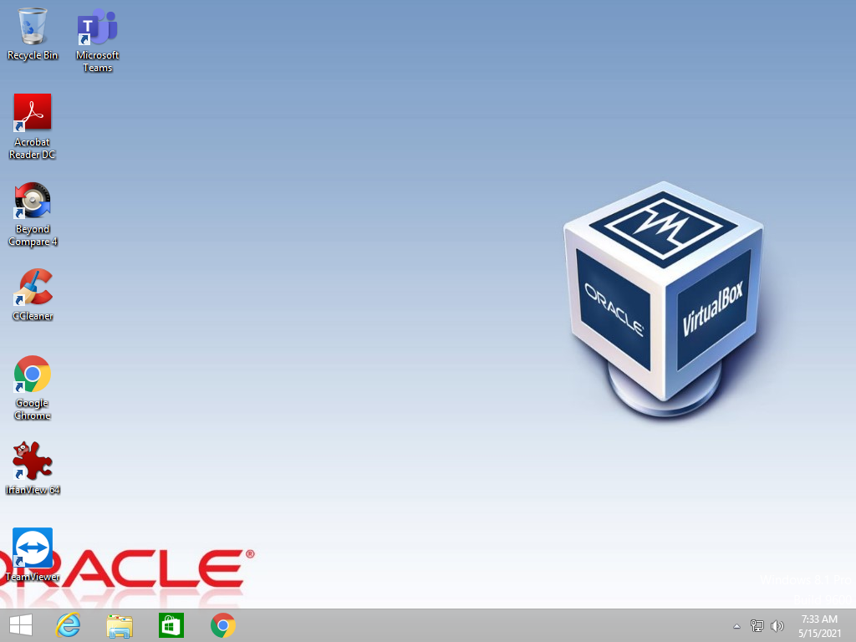

**Windows 10 with POWIS**

